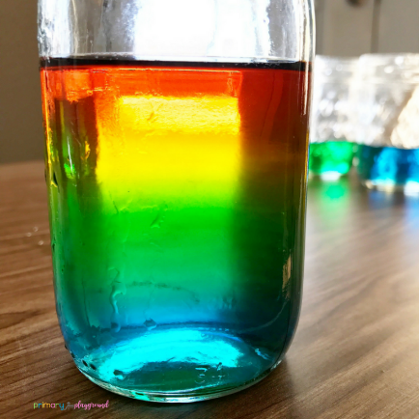 **Science**

Instructions 1: Using sugar

[Rainbow In A Jar Science Experiment - Primary Playground](https://primaryplayground.net/rainbow-in-a-jar-science-experiment/)

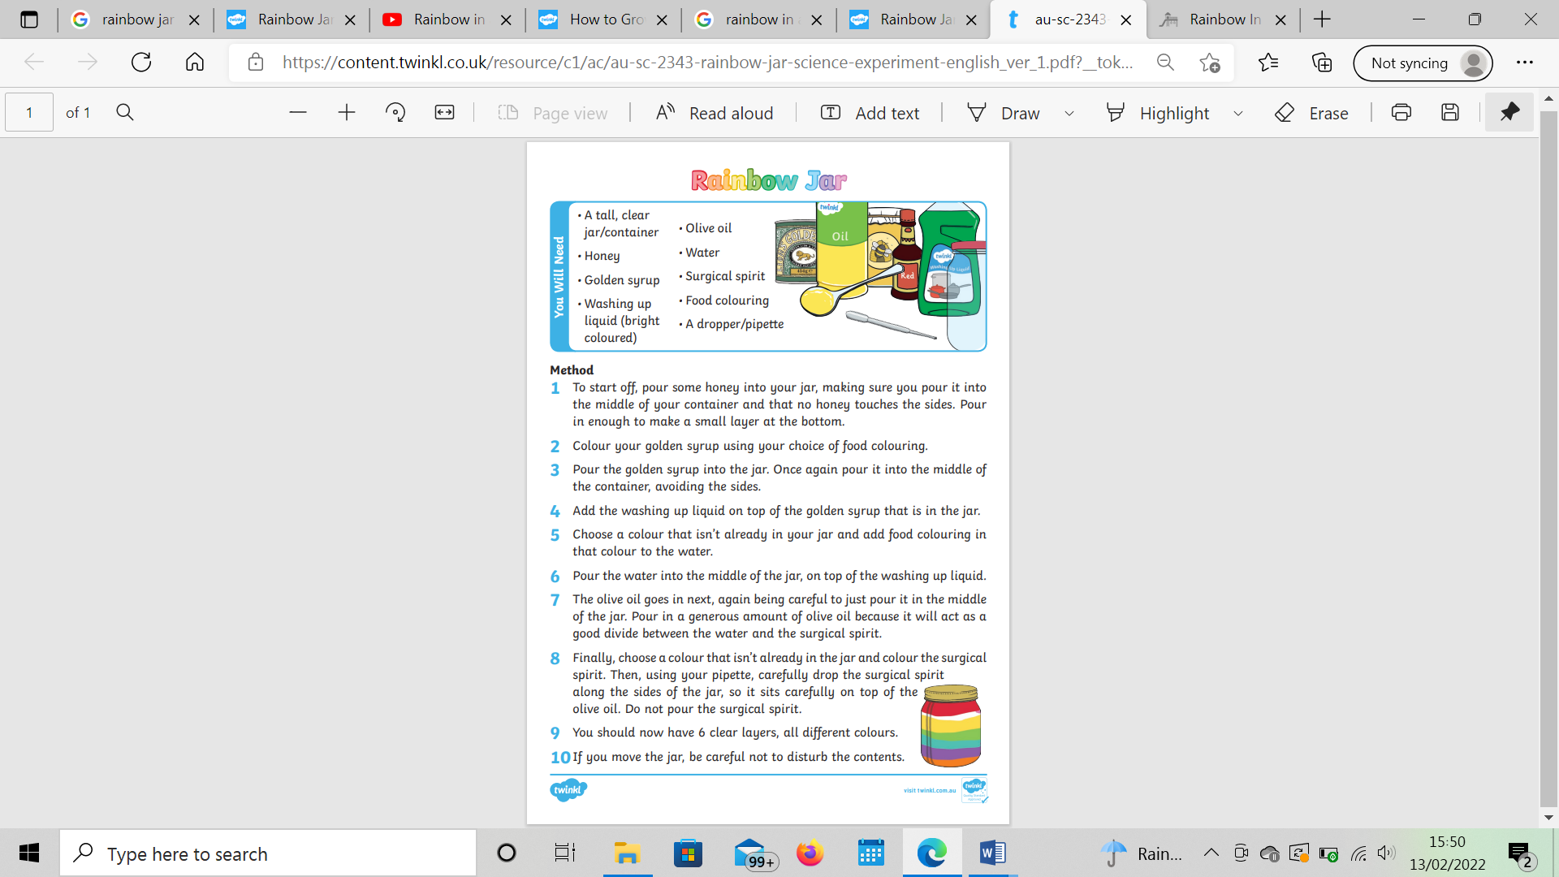Instructions 2: Using different ingredients