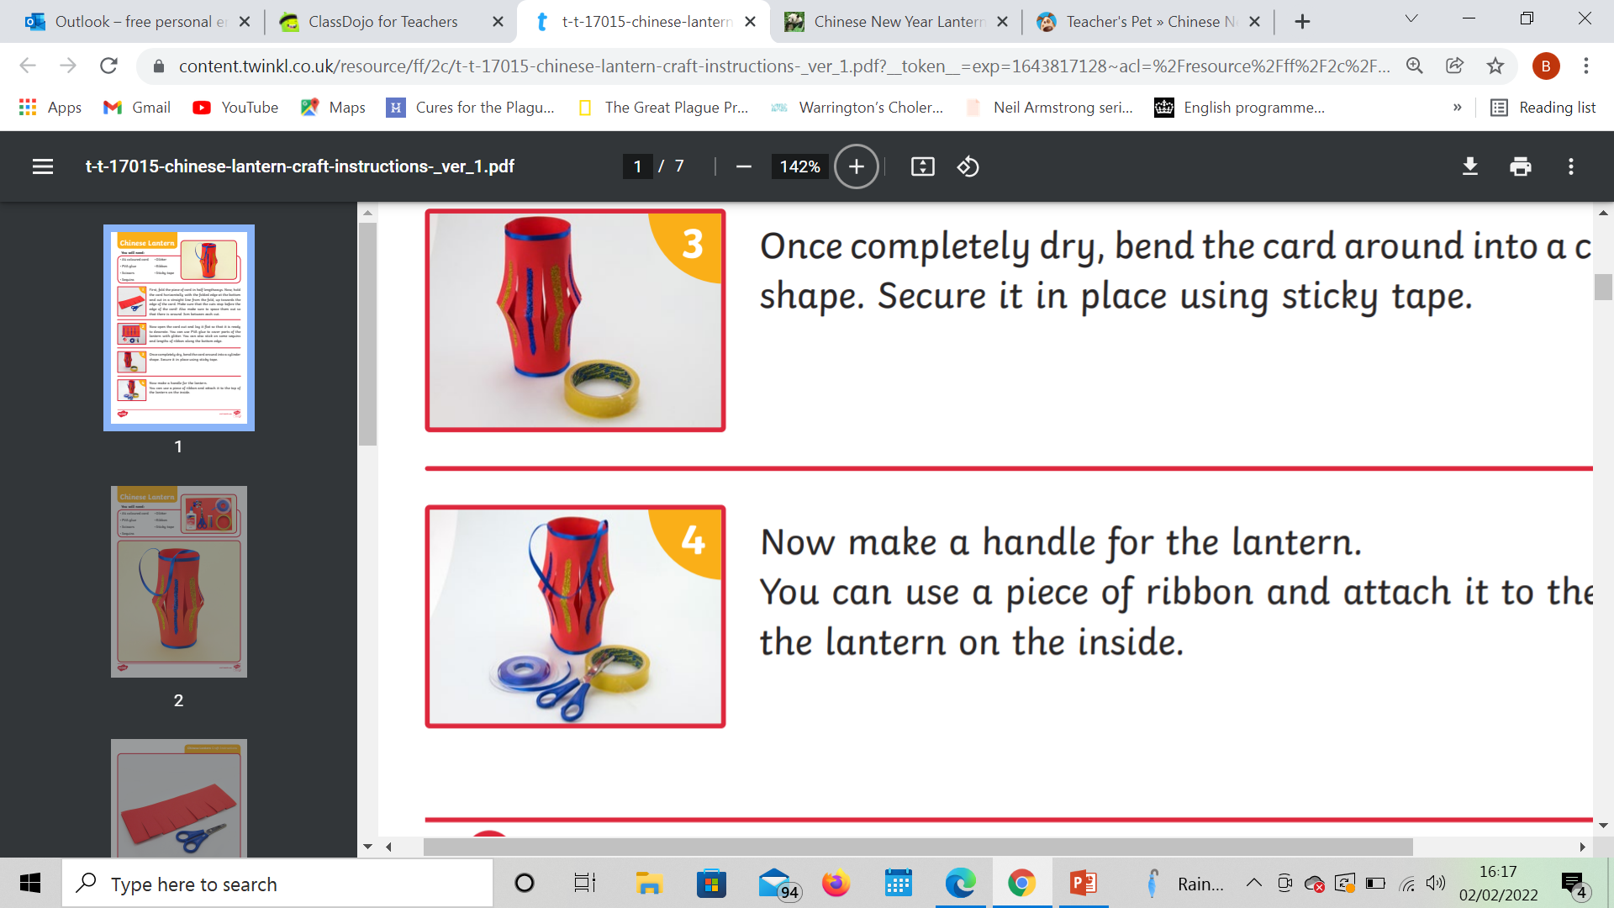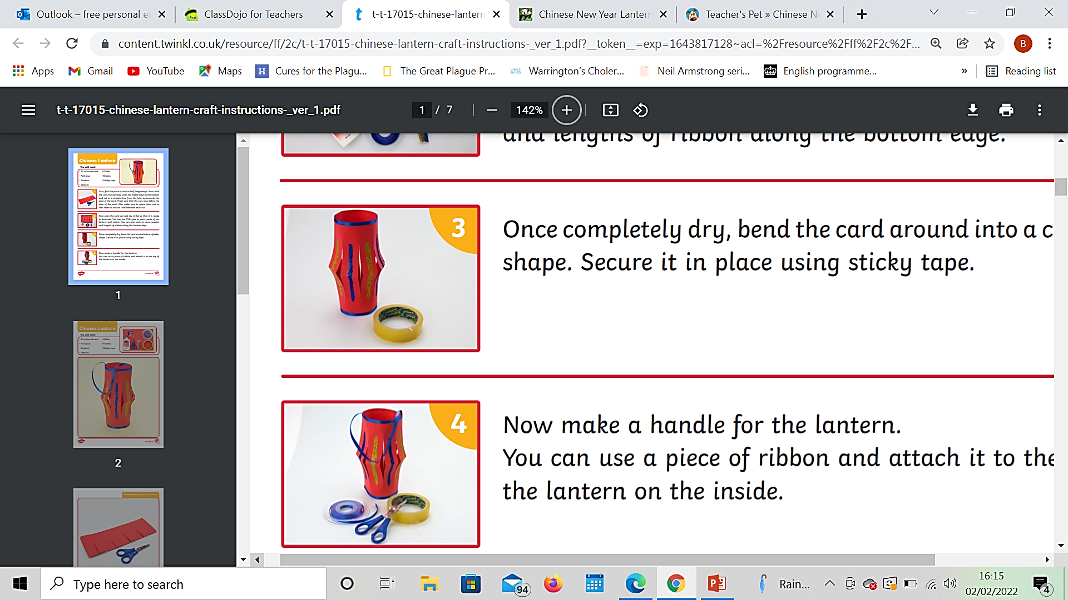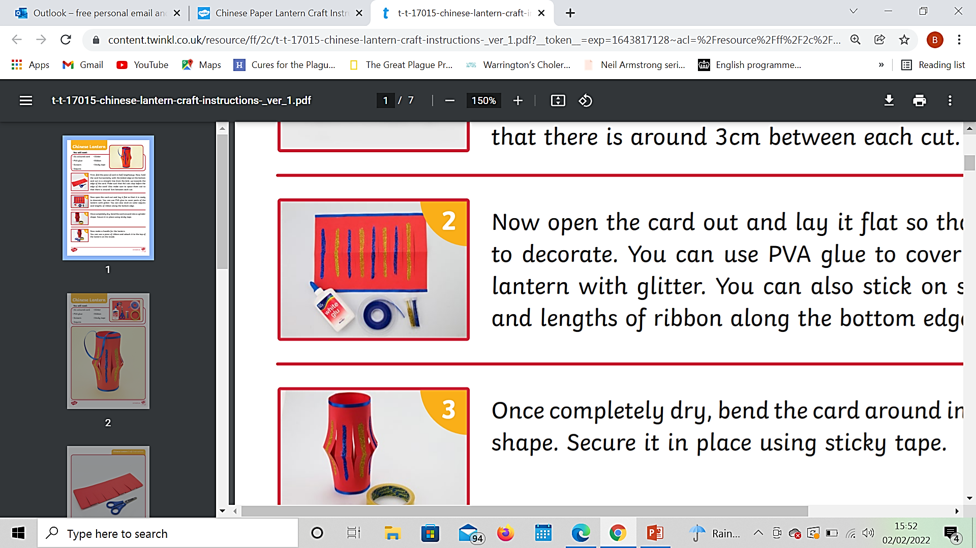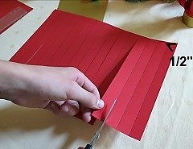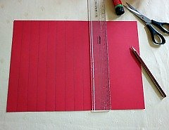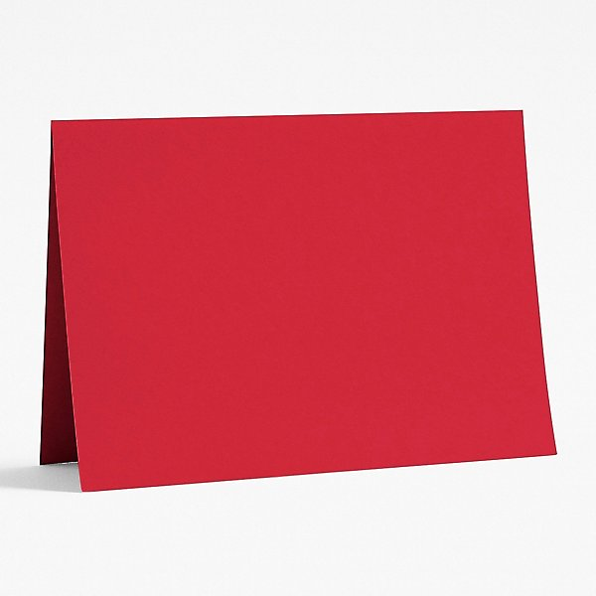

Time Adverbials:

Next First Lastly

Then Secondly To begin with

After that Finally

Verbs:

stick glue cut attach

draw sprinkle

Time Adverbial:

Verb:

Time Adverbial:

Verb:

Time Adverbial:

Verb:

Time Adverbial:

Verb:

Time Adverbial:

Verb: