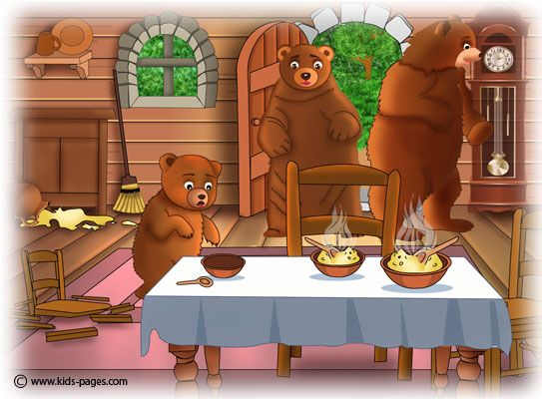
Eventually, the three bears got home in the evening, and found the house in a completely trashed. The bears confronted Goldilocks and she raced out of the house. Mother bear reported, “I feel so upset because someone has ruined our home!’ The bears are deeply distraught and have decided to buy
a lock for their front door.

Three bears find their porridge has been eaten.
Yesterday morning, Goldilocks invited herself into the home of a family of bears. The three bears were shocked to find that Goldilocks had broken into the house. She created a huge mess!

At the start of the day, the three bears went for a picnic in Hutton Forest and left their home empty. Goldilocks was hidden in the woods and snuck inside to explore.

Goldilocks sat in the bears chairs. She was too heavy and broke baby bears wooden chair. After that, she went into the kitchen and ate all of their porridge. She left hardly any food for the bears. Goldilocks moved upstairs where she spotted three beds. After a while, Goldilocks fell asleep in the little bear’s bed.

__________________________________________________________________________________
__________________________________________________________________________________
__________________________________________________________________________________

BEARS HOME RUINED BY GOLDILOCKS!
HUTTON TIMES

Questions:

- What is the headline of the newspaper?
- What did the bears do in Hutton forest?
- What had Goldilocks ate?
- How did Mother Bear feel?
- What did the bears do at the end to try and fix the problem?

