Something has trashed our classroom? What is it?
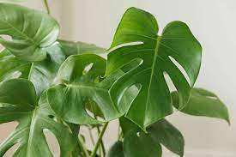

Make a prediction and write a sentence - What is it?

I predict that it is a __________________.

Why do you think this? Can you use ‘because’ and adjectives to describe the clues in the classroom?

I think this because I can see… ____________________________________________________________________________________________________________________________________________________________________________________________

