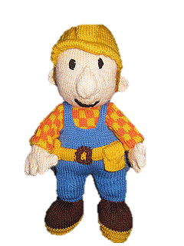
Oh no! Please can you help. Bob the builder has lost the shapes he needs for his house.

Can you hunt for them and name them?

