Ogg Ogg Ogg
My face is a crumpet.
I like to eat marshmallow toast with my banonky- head monkey...
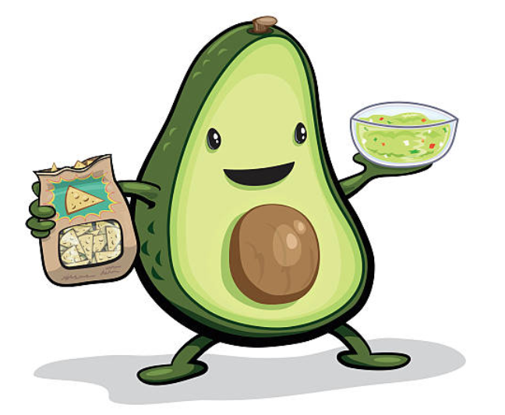
GUACAMOLE!
