Alternative Spellings ‘s’ (‘se’ and ‘st’)

Write all the words that contain the ‘s’ phoneme to match the pictures. Can you write a caption or a sentence for 3 of the pictures.

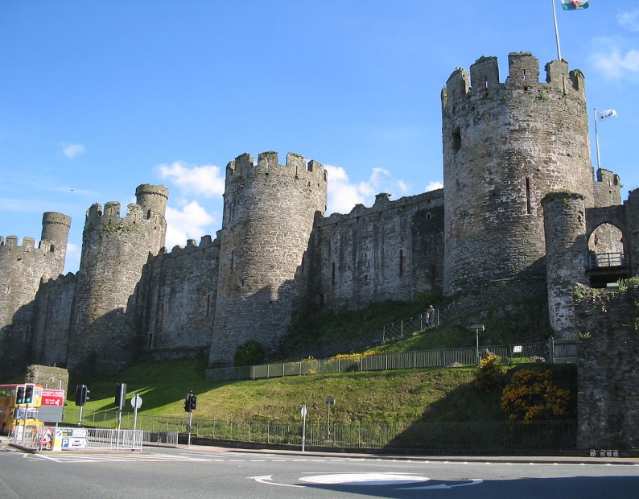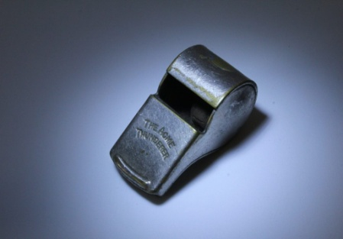=C:\Users\Sue\AppData\Local\Microsoft\Windows\INetCache\IE\N1K1FB6J\Christmas+living+room2[1].gifC:\Users\Sue\AppData\Local\Microsoft\Windows\INetCache\IE\3MDA8NWI\Christmas+living+room2[1].gif