Alternative Spellings ‘y(oo)’ (‘ue/ ‘u-e’ and ‘ew’)

Write all the words that contain the ‘y(oo)’ phoneme to match the pictures. Can you write a caption or a sentence for 3 of the pictures.

C:\Users\Sue\AppData\Local\Microsoft\Windows\INetCache\IE\3MDA8NWI\Irish+Stew[1].gifC:\Users\Sue\AppData\Local\Microsoft\Windows\INetCache\IE\A2N2D2UK\DSC09885[1].gif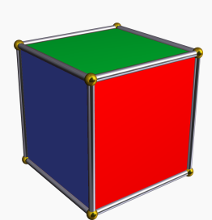=C:\Users\Sue\AppData\Local\Microsoft\Windows\INetCache\IE\N1K1FB6J\hair+photo[1].gifC:\Users\Sue\AppData\Local\Microsoft\Windows\INetCache\IE\3MDA8NWI\wella+5565+koleston+magma+065+special+mix+orange+red+pink+purple+hair+colour[1].gifC:\Users\Sue\AppData\Local\Microsoft\Windows\INetCache\IE\N1K1FB6J\sharing[1].gif