Alternative Spellings ‘igh’ (‘ie’/ ‘y’ and ‘i-e’)

Write all the words that contain the ‘igh’ phoneme to match the pictures. Can you write a caption or a sentence for 3 of the pictures.

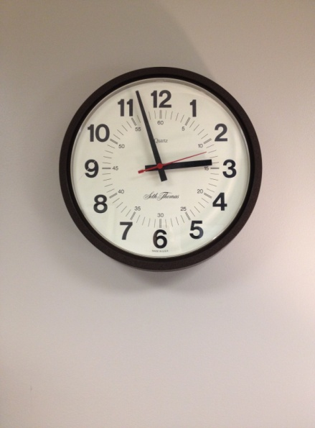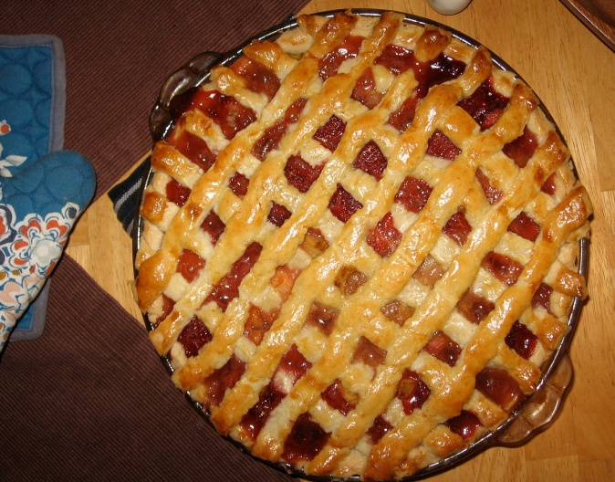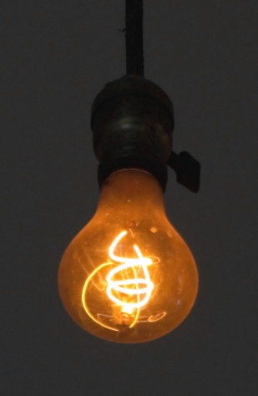C:\Users\Sue\AppData\Local\Microsoft\Windows\INetCache\IE\N1K1FB6J\hair+photo[1].gifC:\Users\Sue\AppData\Local\Microsoft\Windows\INetCache\IE\3MDA8NWI\wella+5565+koleston+magma+065+special+mix+orange+red+pink+purple+hair+colour[1].gifC:\Users\Sue\AppData\Local\Microsoft\Windows\INetCache\IE\N1K1FB6J\sharing[1].gif