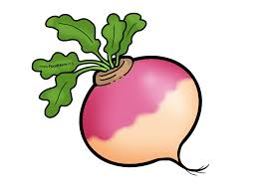
Thursday 25th February 2021

LO: To answer comprehension questions based on a text

- What is the name of the farmer?
___________________________________________________________________________________
- What was his turnip the size of when the judges saw it?
___________________________________________________________________________________
- What month had he planted his turnip?
__________________________________________________________________________________________________________________________________________________________________________

- ‘He was shocked by how big it grew.’ Can you think of another word for shocked?
_______________________________________________________________________________
- What day of the week did the farmer decide to pull the turnip up on?
_________________________________________________________________________________________________________________________________________________________________________

- Who had to help the farmer to pull up the turnip?
__________________________________________________________________________________________________________________________________________________________________________
- How many carrots does the farmer plan on growing for next year’s show?
__________________________________________________________________________________________________________________________________________________________________________

