The Snozzcumber
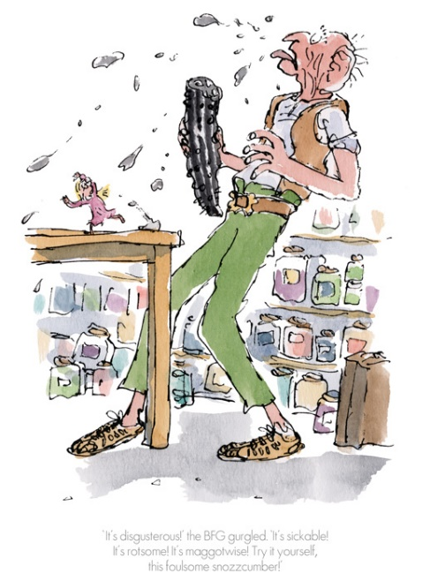
EXTRACT ONE
From Chapter Eight: Snozzcumbers
‘Here is the repulsant snozzcumber!’ cried the BFG, waving it about. ‘I squoggle it! I mispise it! I dispunge it! But because I is refusing to gobble up human beans like the other giants, I must spend my life guzzling up icky-poo snozzcumbers instead. If I don’t, I will be nothing but skin and groans.’
‘Listen’, Sophie said. ‘We don’t have to eat Snozzcumbers’. In the fields around our village there are all sorts of lovely vegetables like cauliflowers and carrots. ‘I is an honourable giant’ he said. ‘I would rather be chewing up rotsome snozzcumbers than snitching things from other people.’

EXTRACT TWO
From Chapter Eight: Snozzcumbers
The BFG was still holding the awesome snozzcumber in his right hand, and now he put one end into his mouth and bit off a huge hunk of it. He started crunching it up and the noise he made was like the crunching of lumps of ice. ‘It’s filthing!’ he spluttered, speaking with his mouth full and spraying large pieces of snozzcumber like bullets in Sophie’s direction. Sophie hopped around on the table-top, ducking out of the way. ‘It’s disgusterous!’ the BFG gurgled. ‘It’s sickable! It’s rotsome! It’s maggotwise! Try it yourself, this foulsome snozzcumber!’ ‘No, thank you,’ Sophie said, backing away. ‘It’s all you’re going to be guzzling around here from now on so you might as well get used to it,’ said the BFG. ‘Go on, you snipsy little winkle, have a go!’ Sophie took a small nibble. ‘Uggggggggh!’ she spluttered. ‘Oh no! Oh gosh! Oh help!’ She spat it out quickly. ‘It tastes of frogskins!’ she gasped. ‘And rotten fish!’ ‘Worse than that!’ cried the BFG, roaring with laughter. ‘

Questions:
- What does the BFG eat? Why?
- How do you feel about the giant?
- Why won’t the giant take cauliflowers and carrots from the gardens in the village?
- Why are Snozzcumbers so important to the BFG?
- Why do you think the author introduces Snozzcumbers to the story?
- Find and copy the similes used to describe how the giant ate the Snozzcumber.
- How did Sophie react to the Snozzcumber?
- Pick out your three favourite adjectives to describe the Snozzcumbers.
- Would you eat a Snozzcumber for the giant? Explain why.

