What is a Fable?

Fables tell us a story and teach us a lesson at the same time and we've been hearing them, retelling them and writing them for over two thousand years.
A fable is a story that features animals, plants and nature which are usually given human qualities such as being able to speak! A fable always ends with a ‘moral’. This is the lesson that is learnt through reading the story.
One of the most famous fables is ‘The Hare and the Tortoise’. In this fable, both animals are can speak and are competing against each other in a race. The arrogant Hare stops to sleep halfway through the race because he is convinced he has enough time to do this and then re-join the race and win it. Meanwhile, the slow but determined Tortoise keeps going and wins while the Hare is asleep.
Most of our best-known fables are thought to have been written by a man called Aesop, who is believed to have been a slave in Ancient Greece around 550BC. That is why a lot of fables are known as ‘Aesop’s Fables’.
Both myths and fables are stories, but myths focus on gods and heroes while fables are stories about animals, objects and nature. Myths aimed to explain the world while fables were intended to provide a lesson to the readers.
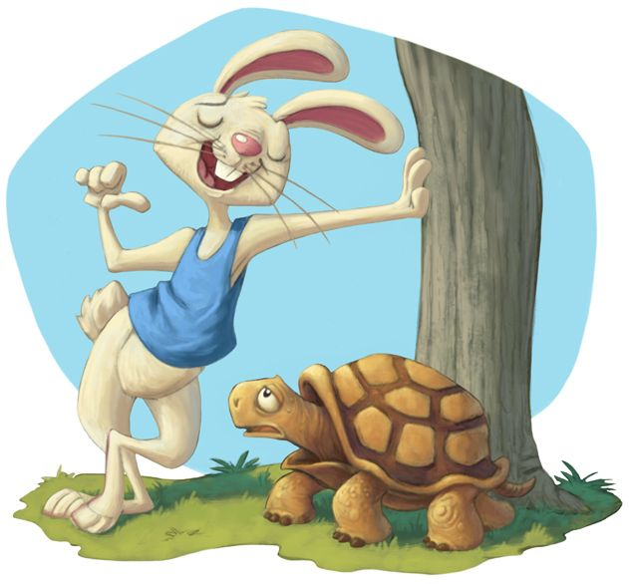

Reading Comprehension
- What are the two things that fables do?
______________________________________________________________________________________________________________________________________
- How long have we been hearing, retelling and writing fables?
___________________________________________________________________
- What three things are usually featured in a fable?
_________________________________________________________________________________________________________________________________________________________________________________________________________
- What are animals, plants and nature usually given in fables?
___________________________________________________________________
- What would the lesson be in ‘The Hare and the Tortoise’ story?
_________________________________________________________________________________________________________________________________________________________________________________________________________
- Write a thought for the Hare and a thought for the Tortoise whilst racing.
Hare: ______________________________________________________________
Tortoise: ___________________________________________________________
- Write two adjectives to describe the Hare’s personality.
______________________________________________________________________________________________________________________________________
- Who had written the best-known fables and what was his job role?
______________________________________________________________________________________________________________________________________
- In your own words and in a full sentence, write a definition for a myth.
______________________________________________________________________________________________________________________________________
- In your own words and in a full sentence, write a definition for a fable.
______________________________________________________________________________________________________________________________________

