Tuesday 12th January 2021

LO: To use question marks in my writing

- Write at least 3 questions about the picture below.

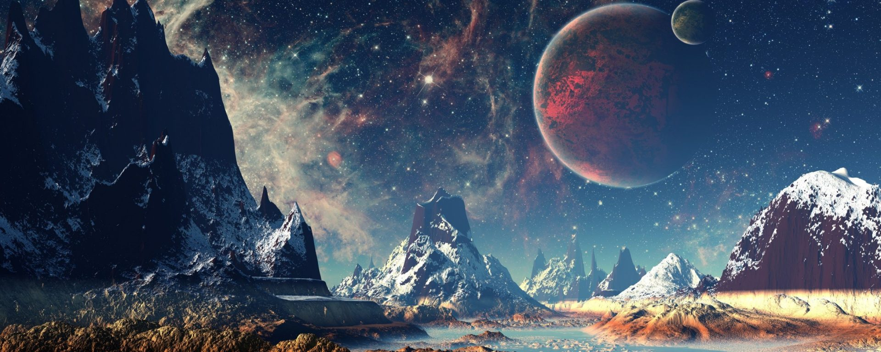

______________________________________________________________________________________________________________________________________________________________________________________________________________________________________________________________________________________________________________________________________________________________________________________________________________________________________________________________________________________________________________________________________________________________________________________________________________________________________________________________________________________________________________________________________________________________________

- Write a question for the following answer: Thousands and thousands of years.

_________________________________________________________________________________________________________
__________________________________________________________________________________________________________

