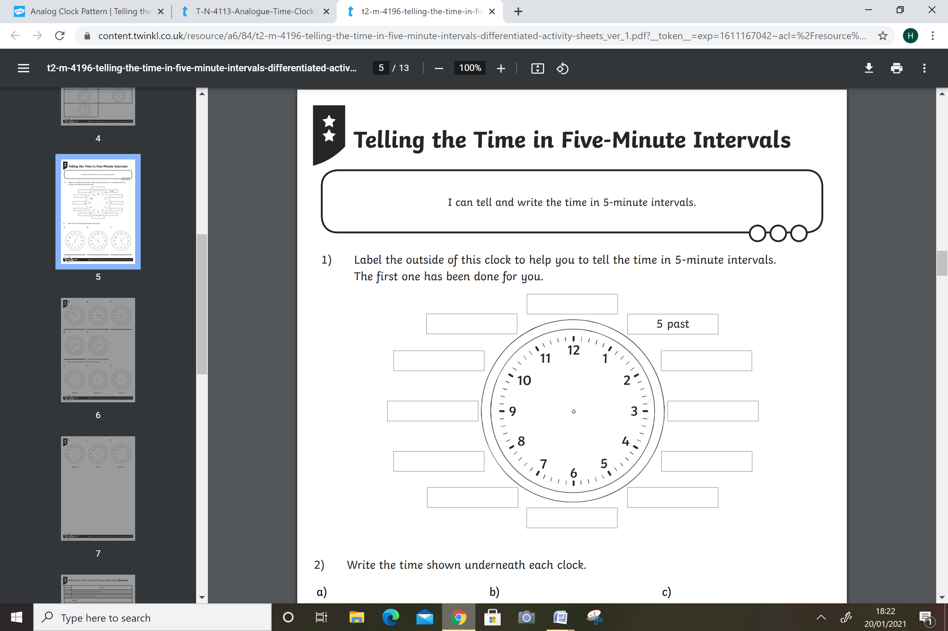

10 past

O’clock

Half past

20 past

20 to

25 to

Quarter to

Quarter past

25 past

10 to

5 to