wandered
vales
host
continuous
bay
glance
sprightly
glee
gay
jocund
wealth
vacant
pensive
bliss
solitude
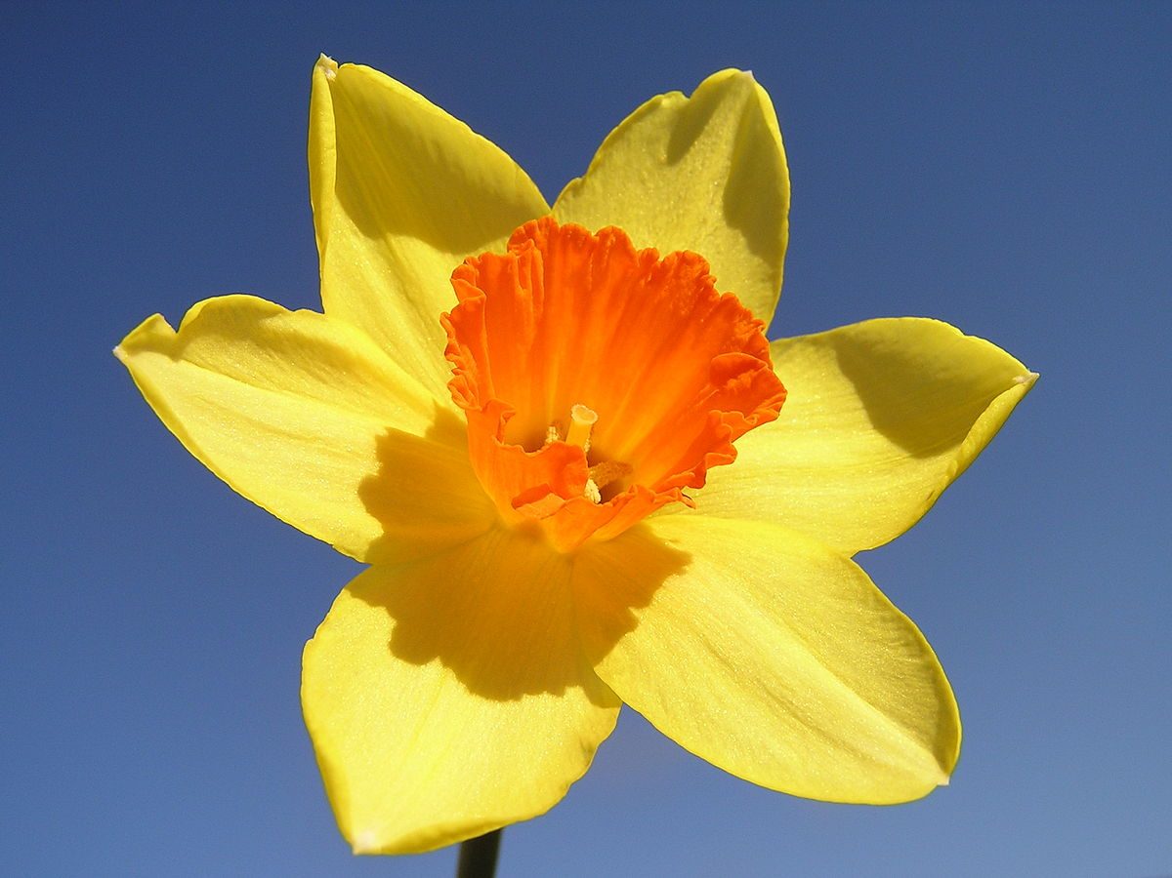
My Daffodils Glossary

Your task is on the next page.

Your Task
Underline or highlight the words in the poem that you do not know. Research and write the meaning of these words. You could use a dictionary or the internet to help you. Feel free to add or take out any words you already know.

