The Star
25th July 1969
AMAZING ASTRONAUTS!
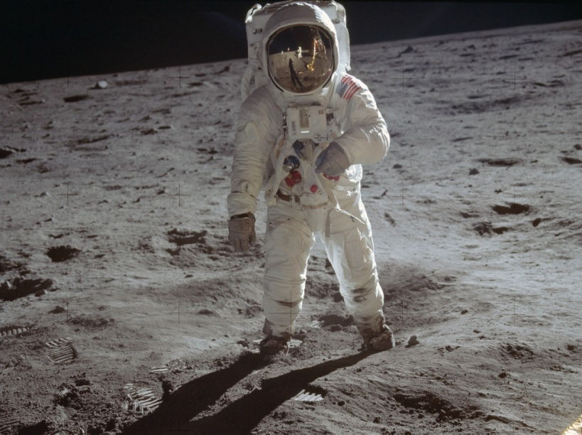 | Report structure ideas
 | Describe the events in order:
- Details of the take off
- Travel time to reach the moon
- Landing on the moon
- Stepping on the moon (climbed down the ladder, footprint, famous quote)
- Taking photographs
- Collecting rock samples
- Planted flag on the moon
- Jumped around on the moon
(Re-watch the moon landing video to help you)
Neil Armstrong on the moon.
Yesterday, something extraordinary happened.
On the 20th July 1969 history was made. | Challenge: You could include interview comments after you have described the moon landing.  Example:  When asked how he felt about the moon landing Armstrong said “I am a very lucky fellow.”  A member of the public said “It was the greatest thing I have ever seen.”
American astronaut, Neil Armstrong was the
first man to step on the moon. Apollo 11 was a
successful mission after tireless preparation.
Firstly, the powerful rocket launched from
the Kennedy Space Station. The enormous
rocket carried three brave astronauts Neil
Armstrong, Buzz Aldrin and Michael Collins.
After travelling 240,000 miles and 76 hours
later the adventurous crew landed on the moon.
It was a moment of amazement.

