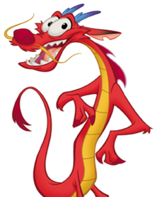
Thursday 14th January 2021

LO: To plan my letter
When do we celebrate New Year?

_______________________________________________________________________________________________
How do you celebrate New Year?

______________________________________________________________________________________________
_____________________________________________________________________________________________
_____________________________________________________________________________________________
_____________________________________________________________________________________________

What questions do you have for Mushu?

_______________________________________________________________________________________________
_______________________________________________________________________________________________
_______________________________________________________________________________________________
_______________________________________________________________________________________________

