The Life of Captain James Cook
James Cook was born on 27th October 1728 in Marton, England. His father was a farmer, but as James grew older he became tempted to explore the sea. At 18, he took an apprenticeship as a merchant seaman in Whitby.
Cook decided to volunteer for the Royal Navy in 1755. His ability at surveying, navigating, and creating large accurate maps was noticed by those high up in the Navy. In 1768 he was given command of the HMS Endeavour. He introduced some strict rules to keep his crew safe and healthy. He required his men to bathe every day, the ship to be kept very clean, and the bedding to be aired twice a week. He also brought lots of fresh fruit to keep his men from getting scurvy.
Cook set off for his first voyage to the South Pacific Ocean on 26th August 1768. His aim was to watch the planet Venus pass between the Earth and the Sun to help astronomers calculate the distance between the Earth and Sun. Afterwards, he was told to head south to search for land. They spotted Australia and went to New Zealand and chartered the coast. Cook and his crewmembers were the first known Europeans to see and chart the east coast of Australia in 1770. Cook returned to England in 1771 having travelled some 30,000 miles and charted over 5,000 miles of coastline to tell of his discoveries.
His second voyage was in 1772-1775. He took two ships the Adventure and the Resolution. They visited New Zealand and Tahiti before returning home to England in 1775. His third and final voyage in 1776-1779 had the aim to find a northwest passage across North America to Asia. He found the Hawaiian Islands and got into a fight with the natives and was killed in 1779.
He created the first accurate map of the Pacific Ocean. Some believe that James Cook’s discoveries helped to create many of the maps of the world.
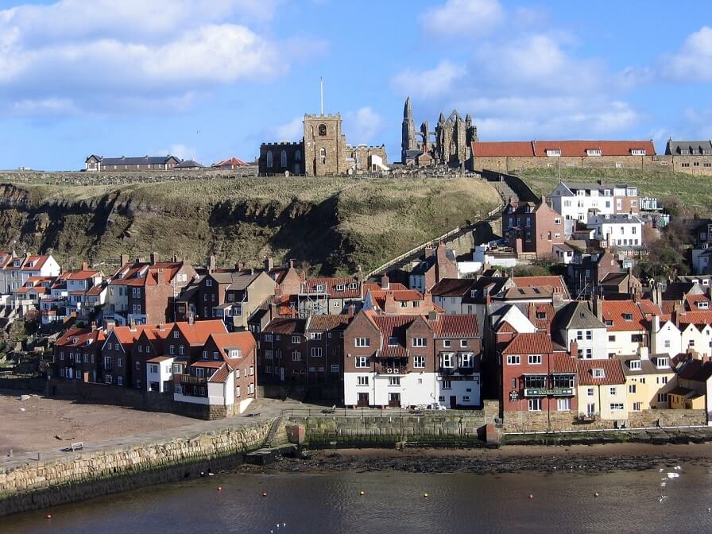
Cut out the pictures and put them in order on paper. Retrieve and write key facts to match each picture from the information above.

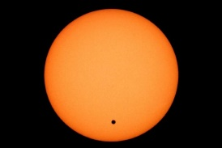
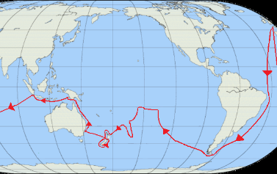
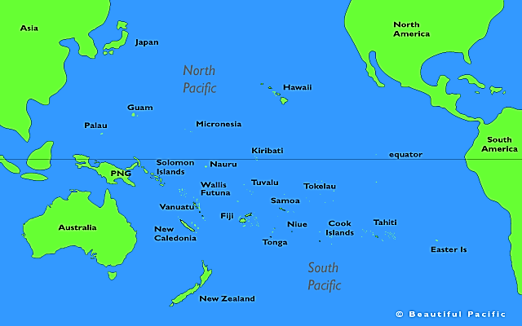

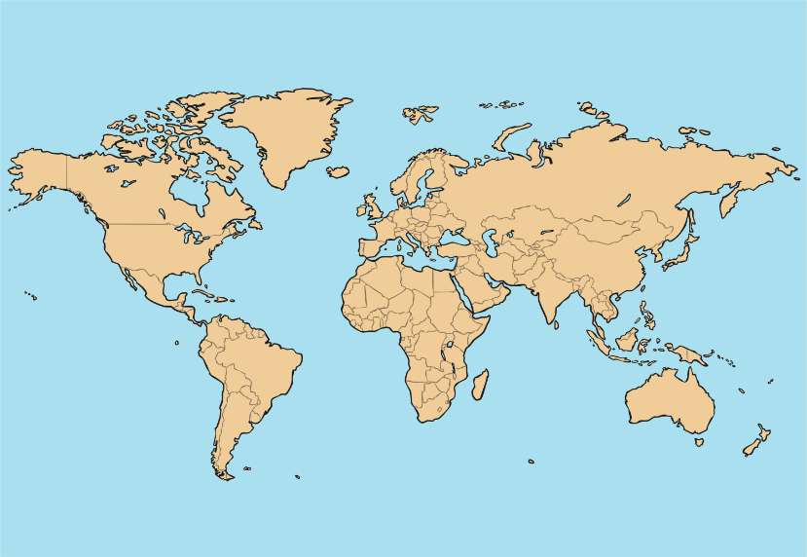
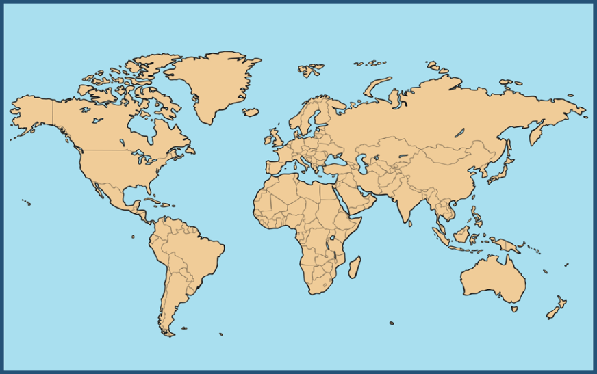
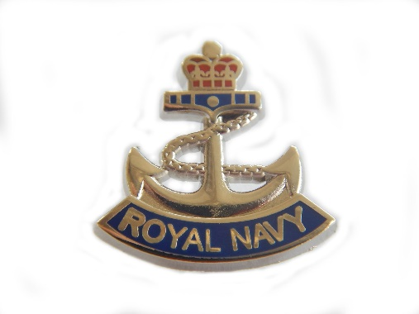
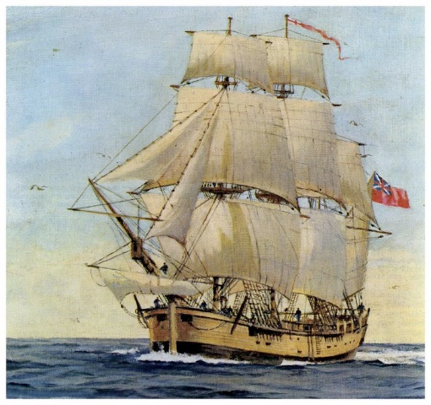
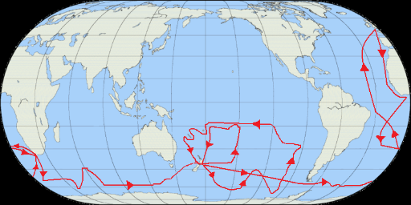
Hawaii
New Zealand and Tahiti

