Wednesday 13th January 2021
Locks Cottage
Fairytale Land
MA11 5GK
12th January 2021
LO: To identify features of a letter

Sender’s address | Greeting | Introduction | More details | Conclusion | From/best wishes | Date
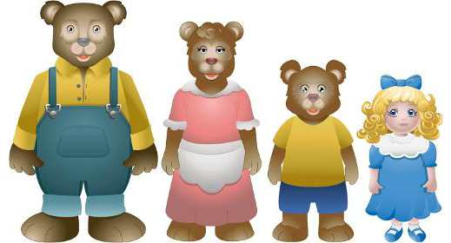
Dear Mother Bear,

How are you? Did Baby Bear have a good birthday? I hope so!

I just wanted to write you a letter to say I’m so sorry that I ate your porridge, slept in your beds and broke your chair! I promise to be good from now on. My Dad has made Baby Bear a brand-new stool for his birthday. Has it reached you yet? I do hope he likes it!

I’m sorry for any upset I may have caused, and I hope you can all forgive me.

Love from,
Goldilocks

