‘ai’
Snail
Tail
Sail
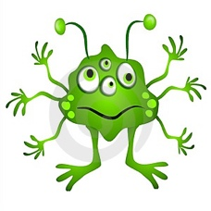
Splaid
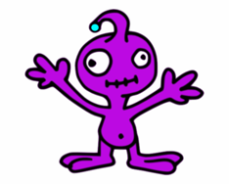
Flaispin
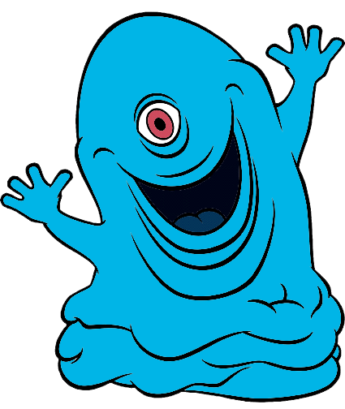
Baips
Spaim
‘ea’
Heat
Meat
Dream
trean
Theat
zlean
Fleam
‘igh’
High
Flight
Might
Tighg
Flighping
Bighps
Splighk
‘ie’
Tie
Pies
Skies
Splied
Fliespin
Thiem
lipie
‘oa’
Foam
Boat
Coat
Toag
Soamp
Spload
Shload
‘ay’
Stay
Crayfish
May
Chaying
Thaym
laypin
zayd
‘ou’
Cloud
Proud
Loud
Sploud
Flousping
Boups
Spoump
‘oy’
Toy
Destroy
Employ
Spoyv
Floysping
Boyps
Spoymp
‘ir’
Thirst
First
Birthday
Tirg
Sirmp
Splirv
Shird
‘ue’
Blue
Clue
Due
Tueg
Suem
Spuev
Shlued
‘aw’
Paws
Saw
Draw
Tawv
Sawmp
Splawd
Shlawd
‘ear’
Clear
Hear
Near
Tearv
Flearpin
Bearps
Speark
‘air’
Hair
Stairs
Hairclip
Tairg
Flairpin
Bairps
Splairk
‘ur’
Fur
Burst
Burn
Turg
Flurpiv
Burld
Splurk
‘er’
Faster
Fern
Perm
Terg
Sermp
Splerd
Shlerv
‘ure’
Manure
Pure
Mixture
Tureg
Surep
Splured
durev

