HUTTON RUDBY PRIMARY SCHOOL
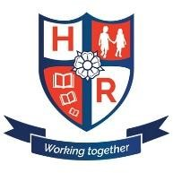
Head Teacher: Mr Matthew Kelly
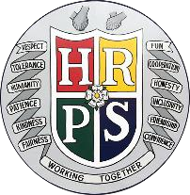
Address: Doctor’s Lane, Hutton Rudby, Yarm, North Yorkshire, TS15 0EQ
Telephone: 01642 700203 Email: admin@huttonrudby.n-yorks.sch.uk
19th October 2020 =
Dear Parents/Carers,

Firstly, as we approach half term can I take this opportunity to say a massive thank you for all your help and support in getting our wonderful children settled back into school and for helping us all with ensuring the children make the best possible start to this academic year. Thank you also for all the positive feedback in terms of the changes we have made to phonics and early reading.

I am writing to you to inform you that we have invested in an additional resource to support reading at home. In order to ensure that children have decodable books available to them in all circumstances, (whether the are attending school or isolating for any reason) we have invested in Rising Stars Reading Planet Online for our Reception and KS1 children. This week your child’s class teacher will send home login details for this resource which can be accessed online at: my.risingstars-uk.com. To provide more detailed information about this and how to log in and use the resource I have recorded a short video that will be available on the Phonics and Early Reading section of our school website as well as on the Reception and KS1 home learning pages.

Please note that all books will be available to the children online but it is vital that they read books at the stage they have been assigned by their class teacher to ensure that what they are accessing links closely to their developing phonics knowledge.

If you have any questions or queries, then please do not hesitate to speak to me on the yard or email me through the admin office.

Miss Ruth Martin
Assistant Headteacher and English Lead

