The Tunnel by Anthony Browne – Lesson 4
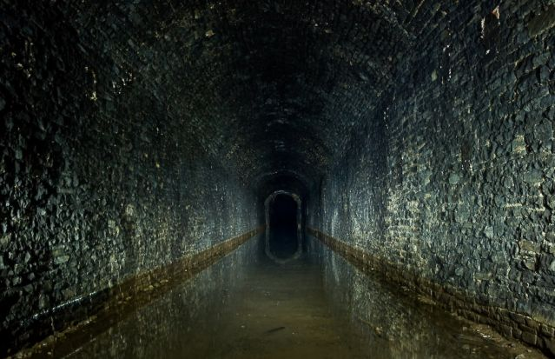
Imagine you are about to crawl through the tunnel.

What was it like in the tunnel?
How do you feel?
What does the ground feel like?
What do the walls feel like?
What can you hear?
What can you see?

Can you write a description of what it would be like inside the tunnel? Remember to use exciting adjectives!

