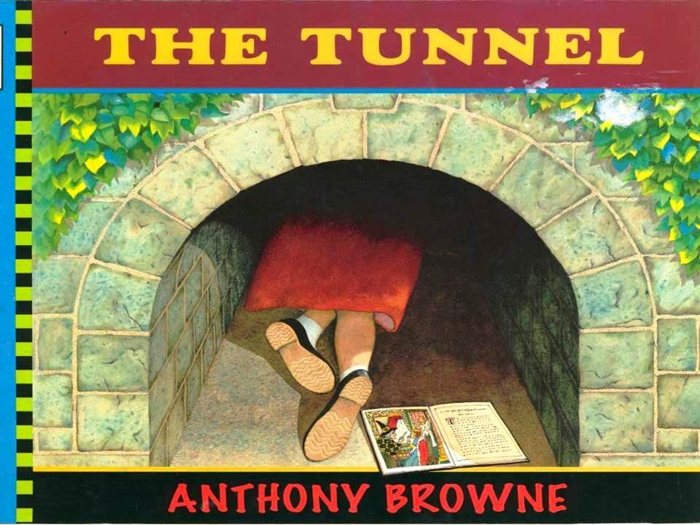

**The Tunnel by Anthony Browne- Lesson 1**

L

Comprehension Questions:

From the front cover what do you think the book will be about?

Do you think the girl will go through the tunnel? Can you explain why you think this?

Where do you think the tunnel leads? Can you give a reason why you think this?

Challenge Questions:

Why do you think the dress is red? What could this mean?

Why is there a book in the picture?