LO: I can write a story about an emotion with a character that I know
1  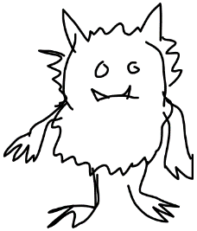 | 2 | 3
This is the colour monster.
He has some empty jars so
off he goes to fill one with
a new emotion…
4 | 5 | 6
The Colour Monster

