LO: I can write sentences about my emotions

If I am feeling angry I can do these things from my calm jar to feel calm again…
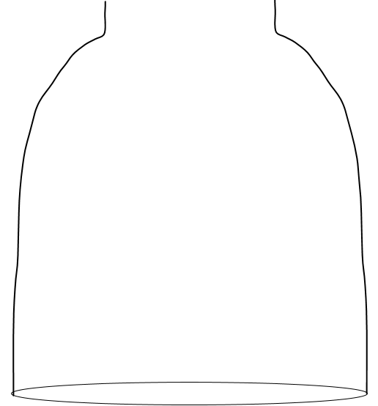

I am calm when I ______  ___________________  ___________________  ___________________ | I am calm____________  ___________________  ___________________  ___________________
I am _______________  ___________________  ___________________  ___________________ | I__________________  ___________________  ___________________  ___________________
___________________  ___________________  ___________________  ___________________ | ____________________  ___________________  ___________________  ___________________

