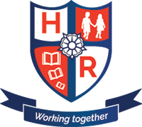
Parent Questionnaire
Proposed Return to School

Please can you complete and send this questionnaire to:
admin@huttonrudby.n-yorks.sch.uk

Name of child/ren:
Year group:

Are you a Key Worker who has not been sending your child/ren into school but now intend to after 1st June?

If your child/ren is in Reception, Year 1 or Year 6, is it your intention to send them back to school as and when school re-opens?

If your child/ren is in Year 2, 3, 4 or 5, is it your intention to send them back to school if and when school re-opens for those year groups?

Any other comments that you feel would support any proposed phased return to school.

