
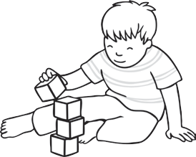
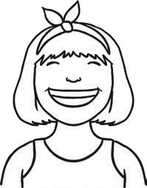
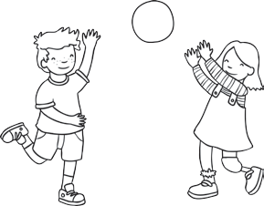
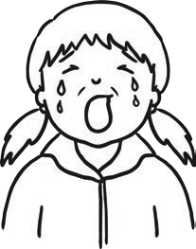
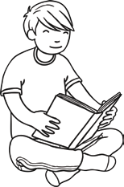
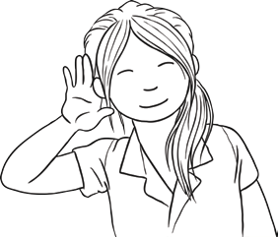
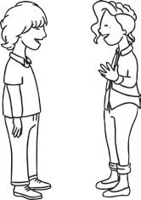
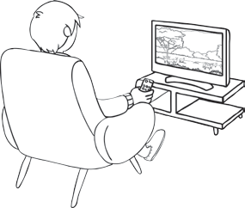
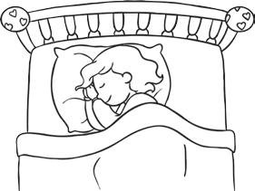
Verbs
Fill in the gaps using the right verb from the box.
1.
2.
3.
4.
5.
6.
7.
8.
9.
We with our toys and games.
I
when I am sad.
At school, we
to the teacher.
At night, I in bed.
You can on the phone. I can lots of books.
You can a tower with bricks. I when I am happy.
We films on the TV.
10. I my lunch at school.
visit twinkl.com
Page 1 of 3

eat

build

smile

play

cry

read

listen

talk

watch

sleep

visit twinkl.com

