The River by Valerie Bloom
The River's a wanderer,
A nomad,
a tramp,
He never chooses one place
To set up his camp.
The River's a winder,
Through valley and hill,
He twists and he turns
He just cannot be still.
The River's a hoarder,
And he buries down deep
Those little treasures
That he wants to keep.
The River's a baby,
He gurgles and hums,
And sounds like he's happily Sucking his thumbs.
The River's a singer,
As he dances along,
The countryside echoes
The notes of his song.
The River's a monster,
Hungry and vexed,
He's goggled up trees
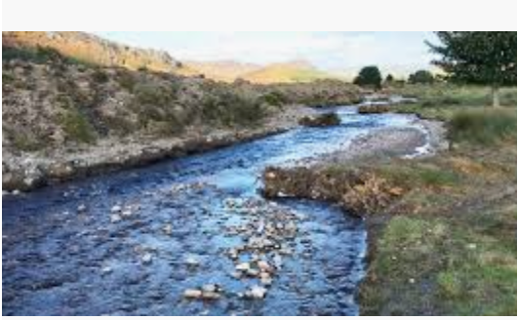
And he'll swallow you next.

