Y1 Objective: Sequence events chronologically. Use language such as:
before, after, first, next, yesterday, today, tomorrow, morning, afternoon, evening.

Use a word from above to complete each sentence. Choose wisely!
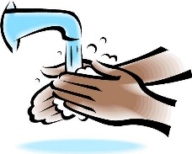
- I have my lunch I wash my hands.

- I won the race because I came .

- I go to bed in the .

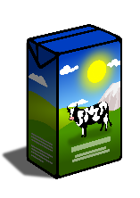
- In the I eat my breakfast.

- We drink our cartons of milk in the .

- We have pudding our lunch.

- Today it is Wednesday. it was Tuesday.

- it will be Thursday.

Can you write a sentence of your own. Choose a word from above.

Write these time words on labels to put around your map! It would be great to use as many as you can in your weather forecast!
Challenge:
Example: Yesterday I played with my sister at lunchtime.
Complete a sentence of your own for the following words:

Yesterday I…

Today I…

Tomorrow I…

Last week I…

Tonight I…

Next year I…

Complete the table.
Yesterday was | Today is | Tomorrow will be
Tuesday | Wednesday | Thursday
Friday |  | Sunday
Monday
Saturday
 | Friday
 |  | Wednesday

