24.3.20

Cut and sort the words on the second page into which ones mean + and which ones mean -

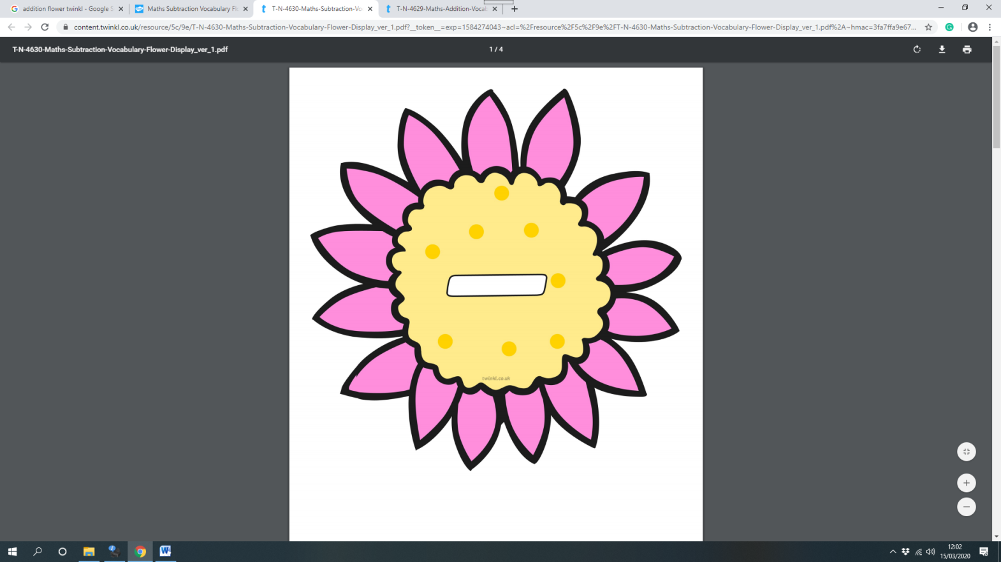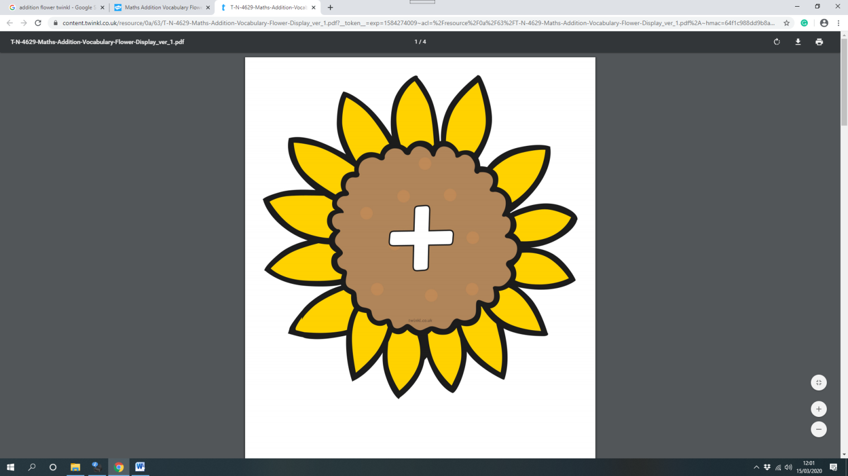

total

subtract

more

Challenge:

difference between

take away

add

altogether

sum

plus

less

minus

leaves

make