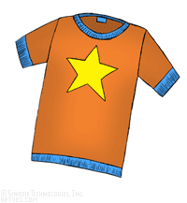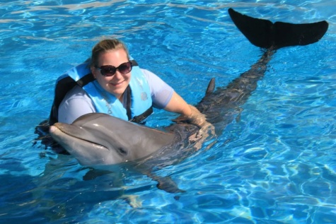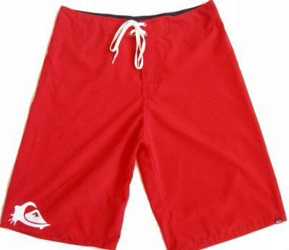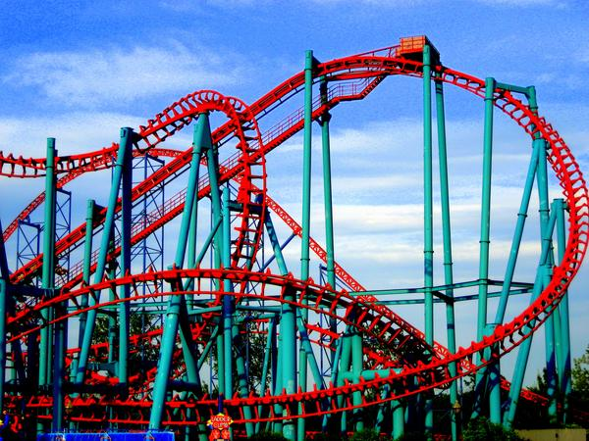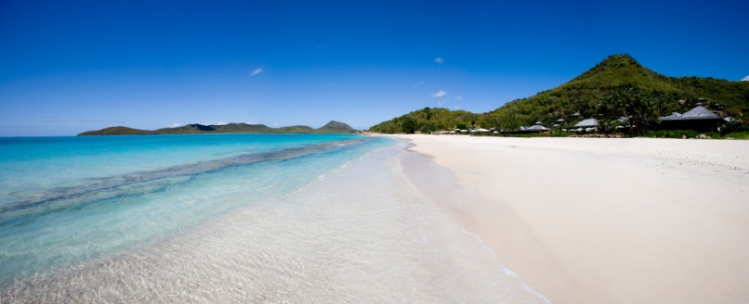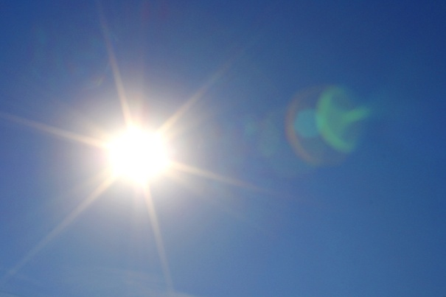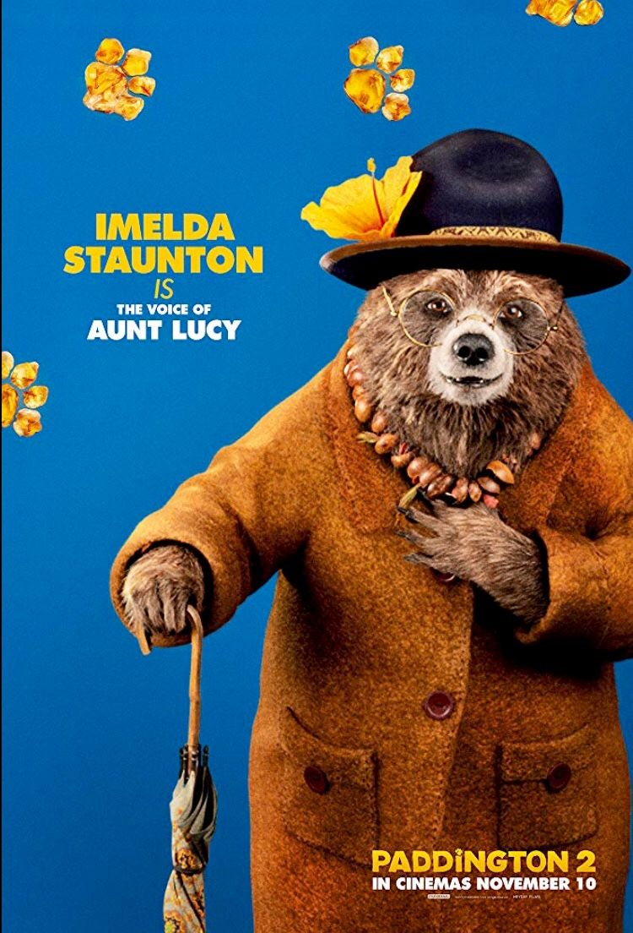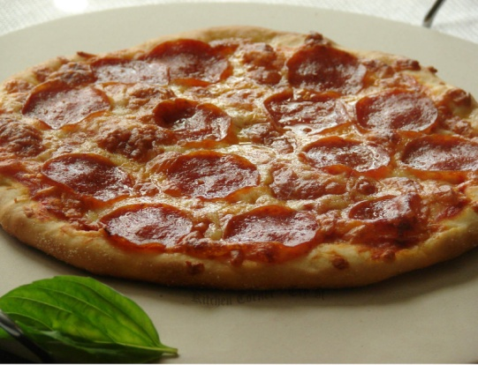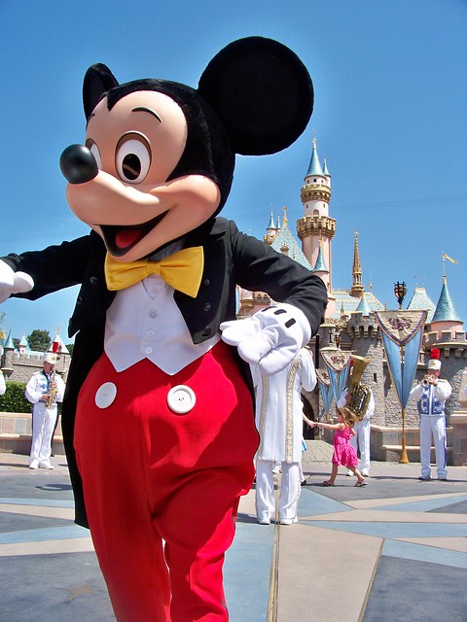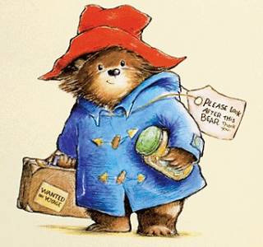

I saw Mickey Mouse.

I went with Aunt Lucy.

I swam with dolphins.

I watched a firework display.

I went on rollercoaster’s.

It was boiling.

I went to the beach.

I wore shorts and t-shirts.

I ate pizza.

Here is my postcard plan! Can you create a plan?

Can you think of your favourite holiday and create a plan for your postcard?

You could find your favourite holiday photos and make a collage. You could draw pictures of your holiday or make a spider diagram. It would be great if you could add labels to remind yourself of what you did on holiday.

(Think about the weather, what activities you did, what you wore, your senses and who you were with)