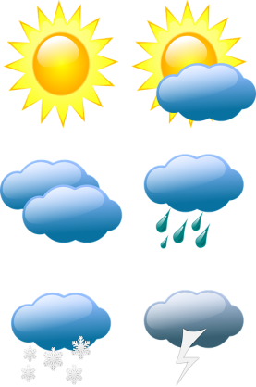
Weather Forecast Script Plan!
Plan your Introduction

News Reporter
What is your News Reporter name? Ex: Miss Palmer
________________________________________
What is your News Channel called? Ex: Hutton News
________________________________________
Introduction: (You could interview someone in your house)
Example: Hello and welcome to Hutton Rudby News with Miss Palmer as your reporter. Today’s top story Hutton Rudby has got a new member of staff called Miss Martin.
Sentence starter ideas:
Hello and welcome to...
Good morning / afternoon / evening....

What would you look like as a News Reporter? What would you wear?
Draw a picture of yourself as a News Reporter! (You could add labels)

