Write a word to describe the sound that you hear:


A. ____________________

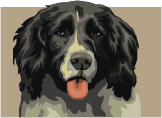
B. ___________________


C. ____________________

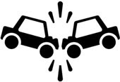
D. ____________________


E. ____________________


F ____________________


G. ____________________


H. _______________________

1
Challenge:
Use onomatopoeia in a sentence.

a. boom _________________________________________

_____________________________________________________

b. ouch _________________________________________

_____________________________________________________

c. bang _________________________________________

_____________________________________________________

d. crash _________________________________________

_____________________________________________________

e. splash _________________________________________

_____________________________________________________

f. squeak _________________________________________

_____________________________________________________

