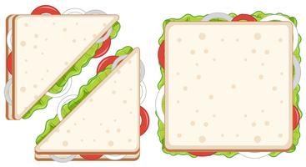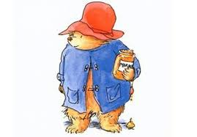

Can you cut your sandwich into quarters?

Remember a quarter is four __________ parts

How do you write a quarter? ________

(Draw lines on the sandwich to cut it into

quarters and shade 1 quarter )

Can you cut your sandwich in half?

Remember a half is two __________ parts

How do you write a half? ________

How many different ways can you cut your

sandwich in half? (Draw the lines on the sandwich to

split it in half)

Paddington loves marmalade sandwiches!

Can you make your favourite sandwich at home?