Map out your story!
Can you remember when you made a Beegu story map? It might have looked like this....
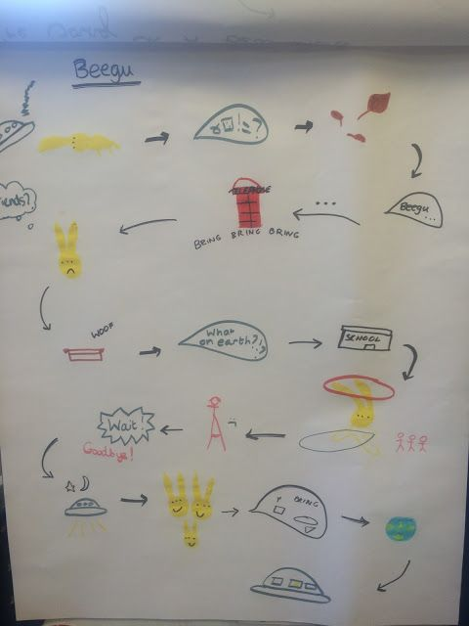
Can you create your own story map for your dinosaur story? You might want to use the layout below or if you would create your own layout like the one above that is fine!

Map out your story!
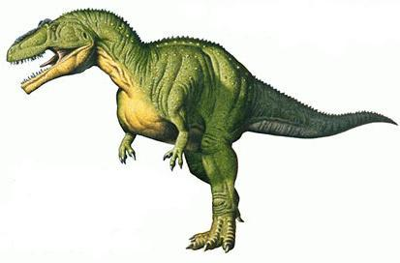
Story title: ______________________
Beginning
Build-Up
Ending
Resolution- How does your character solve the problem?
Problem or main event!

