A_Colorful_Cartoon_Boy_Using_a_Magnifying_Glass_To_Investigate_Royalty_Free_Clipart_Picture_100807-204968-003053[1]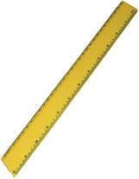

1. Measure your **hand span** using your hand print and a **ruler**.

**2. My hand span measures \_\_\_\_\_\_\_\_\_\_ cm.**

3. Investigate and measure objects around your home and compare them to your hand span.

4. Record your results in the diagram below.

|  |  |
| --- | --- |
| **pencil_color[1]Longer than my hand span** | **Shorter than my hand span** |
|  |  |

