**Tom had 26 coins in a piggy bank. His dad gave him 6 more coins as pocket money. How many coins does he have now?**

**C:\Users\rlove1.306\AppData\Local\Microsoft\Windows\Temporary Internet Files\Content.IE5\PIEO9LZ1\MC900264268[1].wmfA packet has 5 sweets inside. How many sweets would there be in 3 packets?**

**C:\Users\rlove1.306\AppData\Local\Microsoft\Windows\Temporary Internet Files\Content.IE5\97IP5H6K\MC900112658[1].wmfThere are 30 biscuits on a plate. 13 get eaten. How many are left now?**

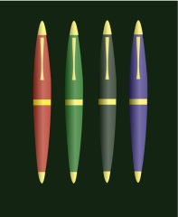**Ben has 8 pens. Sam has 10 pens. How many pens do they have altogether?**

**Some hens lay 6 eggs, 4 eggs and 8 eggs. How many eggs altogether?**