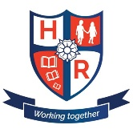
Hutton Rudby Primary School
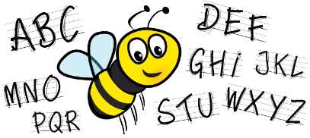
Challenge Words

- question
- quarter
- purpose
- promise
- probably
- pressure
- potatoes
- possible
- possession
- possesses

