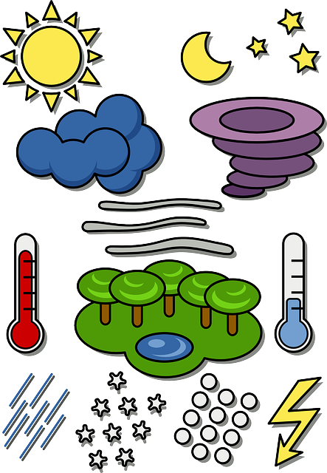

Features of a Weather Forecast

Days of the week

What do I need to include in a Weather Forecast?