**How many words can you think of to describe a T-Rex?**

**Remember to spell using your phonics! Use the mat in your Phonics Support Pack to help you.**

**TASK: Think about what a T-Rex looks like. You could also label the body parts of the dinosaur.**

**For a challenge can you think of any words to describe the dinosaurs personality and movements?**

**speedy**

**massive**

**Tyrannosaurus- Rex**

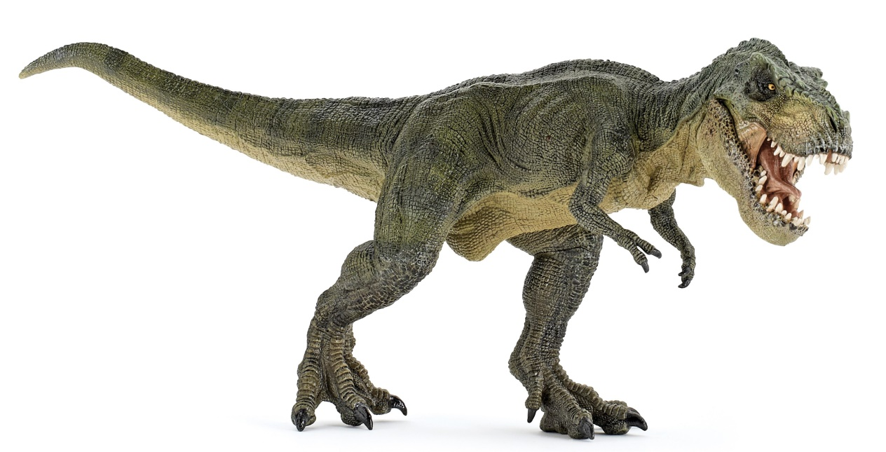

**evil**

**How many words can you think of to describe a Stegosaurus?**

**Remember to spell using your phonics! Use the mat in your Phonics Support Pack to help you.**

**TASK: Think about what a Stegosaurus looks like. You could also label the body parts of the dinosaur.**

**For a challenge can you think of any words to describe the dinosaurs personality and movements?**

**Stegosaurus**

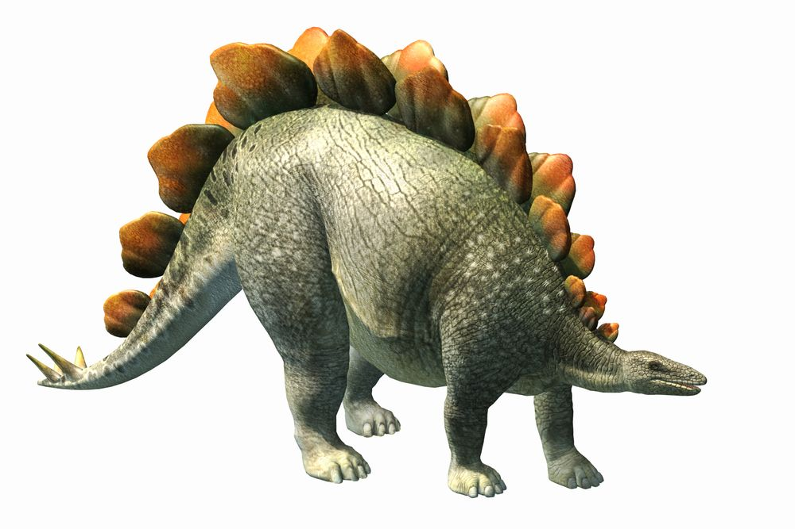

**sneaky**

**stomps**

**bumpy**

**How many words can you think of to describe a Diplodocus!**

**Remember to spell using your phonics! Use the mat in your Phonics Support Pack to help you.**

**TASK: Think about what a Diplodocus looks like. You could also label the body parts of the dinosaur.**

**For a challenge can you think of any words to describe the dinosaur’s personality and movements?**

**Diplodocus**

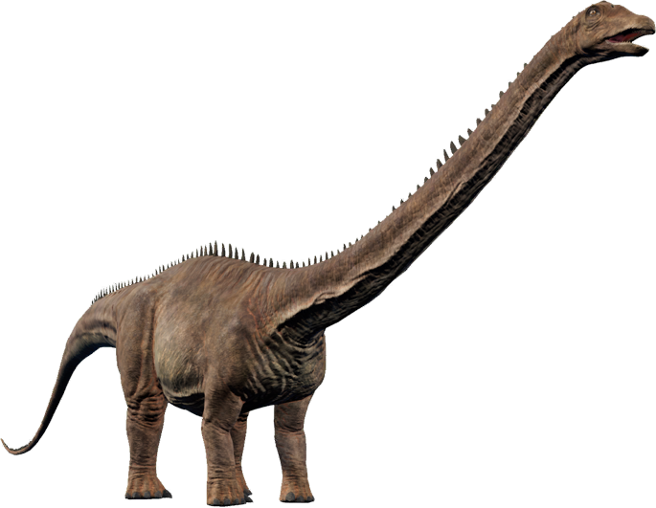

**clever**

**stomps**

**tall**