**Tom had 5 coins. His dad gave him 5 more coins.**

**How many coins does he have now?**

**C:\Users\rlove1.306\AppData\Local\Microsoft\Windows\Temporary Internet Files\Content.IE5\PIEO9LZ1\MC900264268[1].wmf**

**There are 10 sweets on a plate. 7 get eaten. How many are left now?**

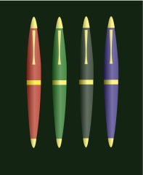

**Ben has 8 pens. Sam has 2 pens. How many pens do they have altogether?**

**Dan has 8 cakes. Jon has 6 cakes. How many cakes are there in total?**