**DINOSAUR FOOTPRINTS**

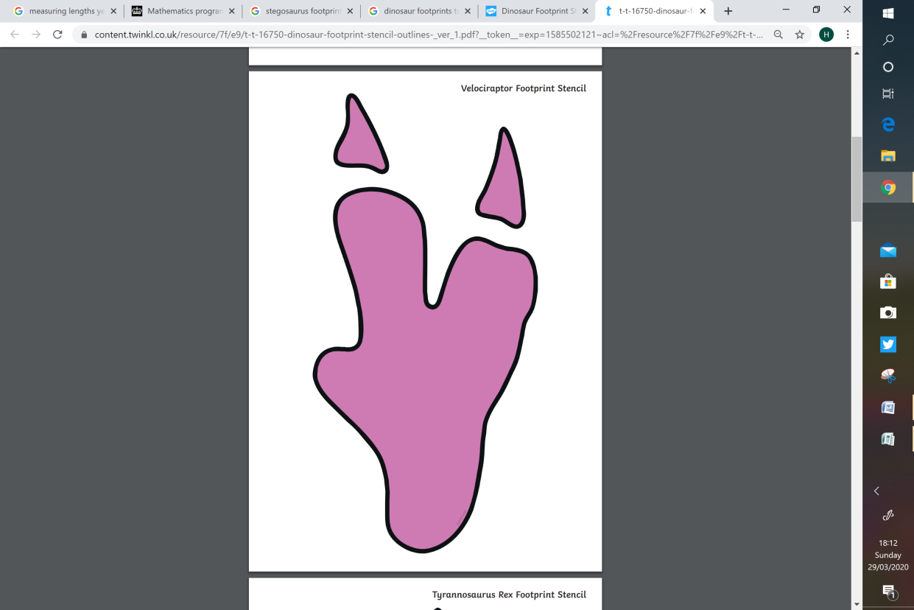Can you measure the footprints using a ruler?

**Velociraptor**

**Triceratops** 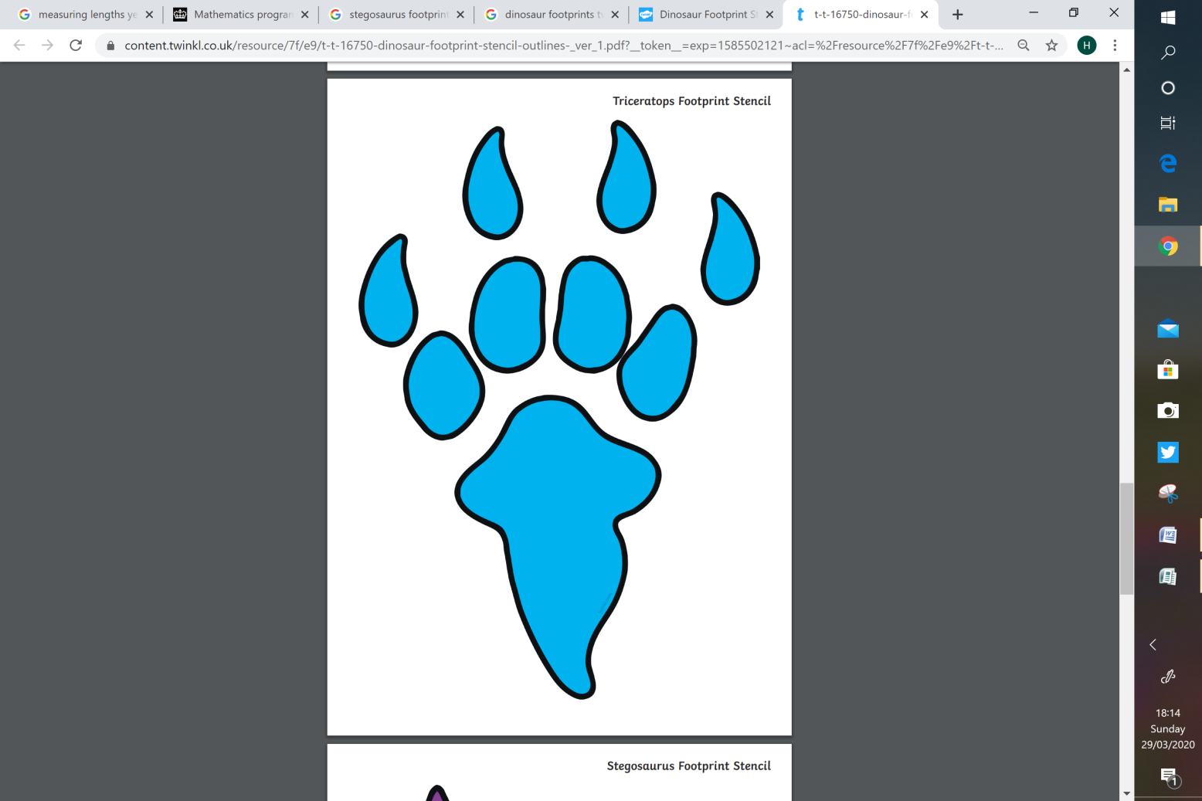

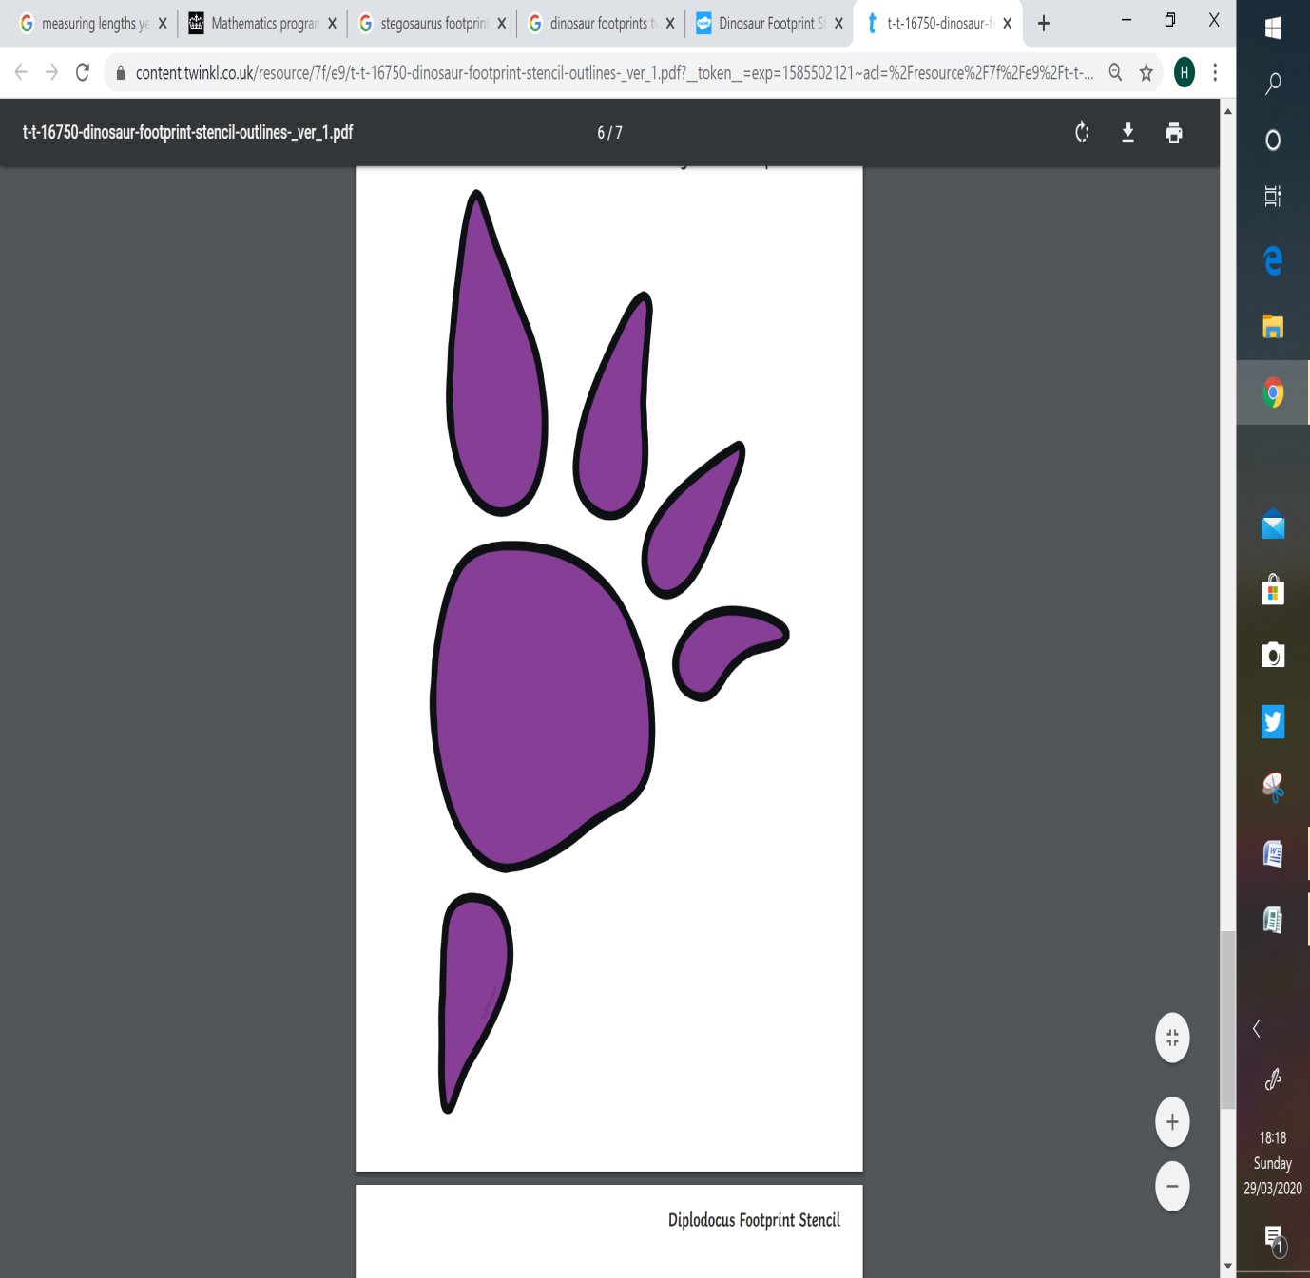

**Stegosaurus**

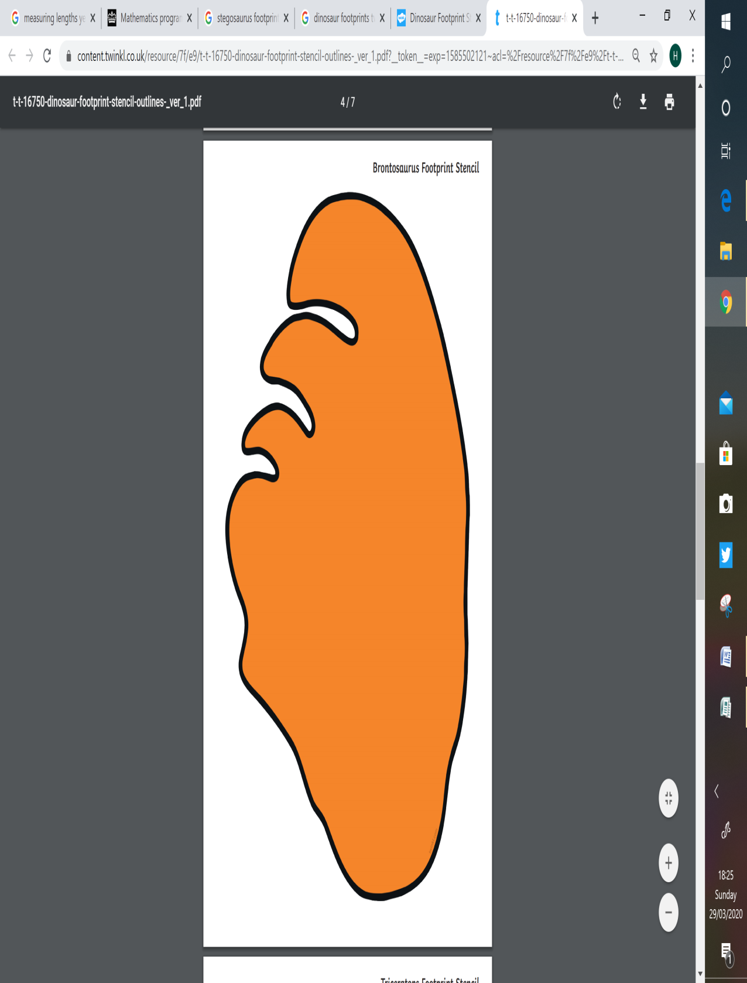 **Brontasaurus**

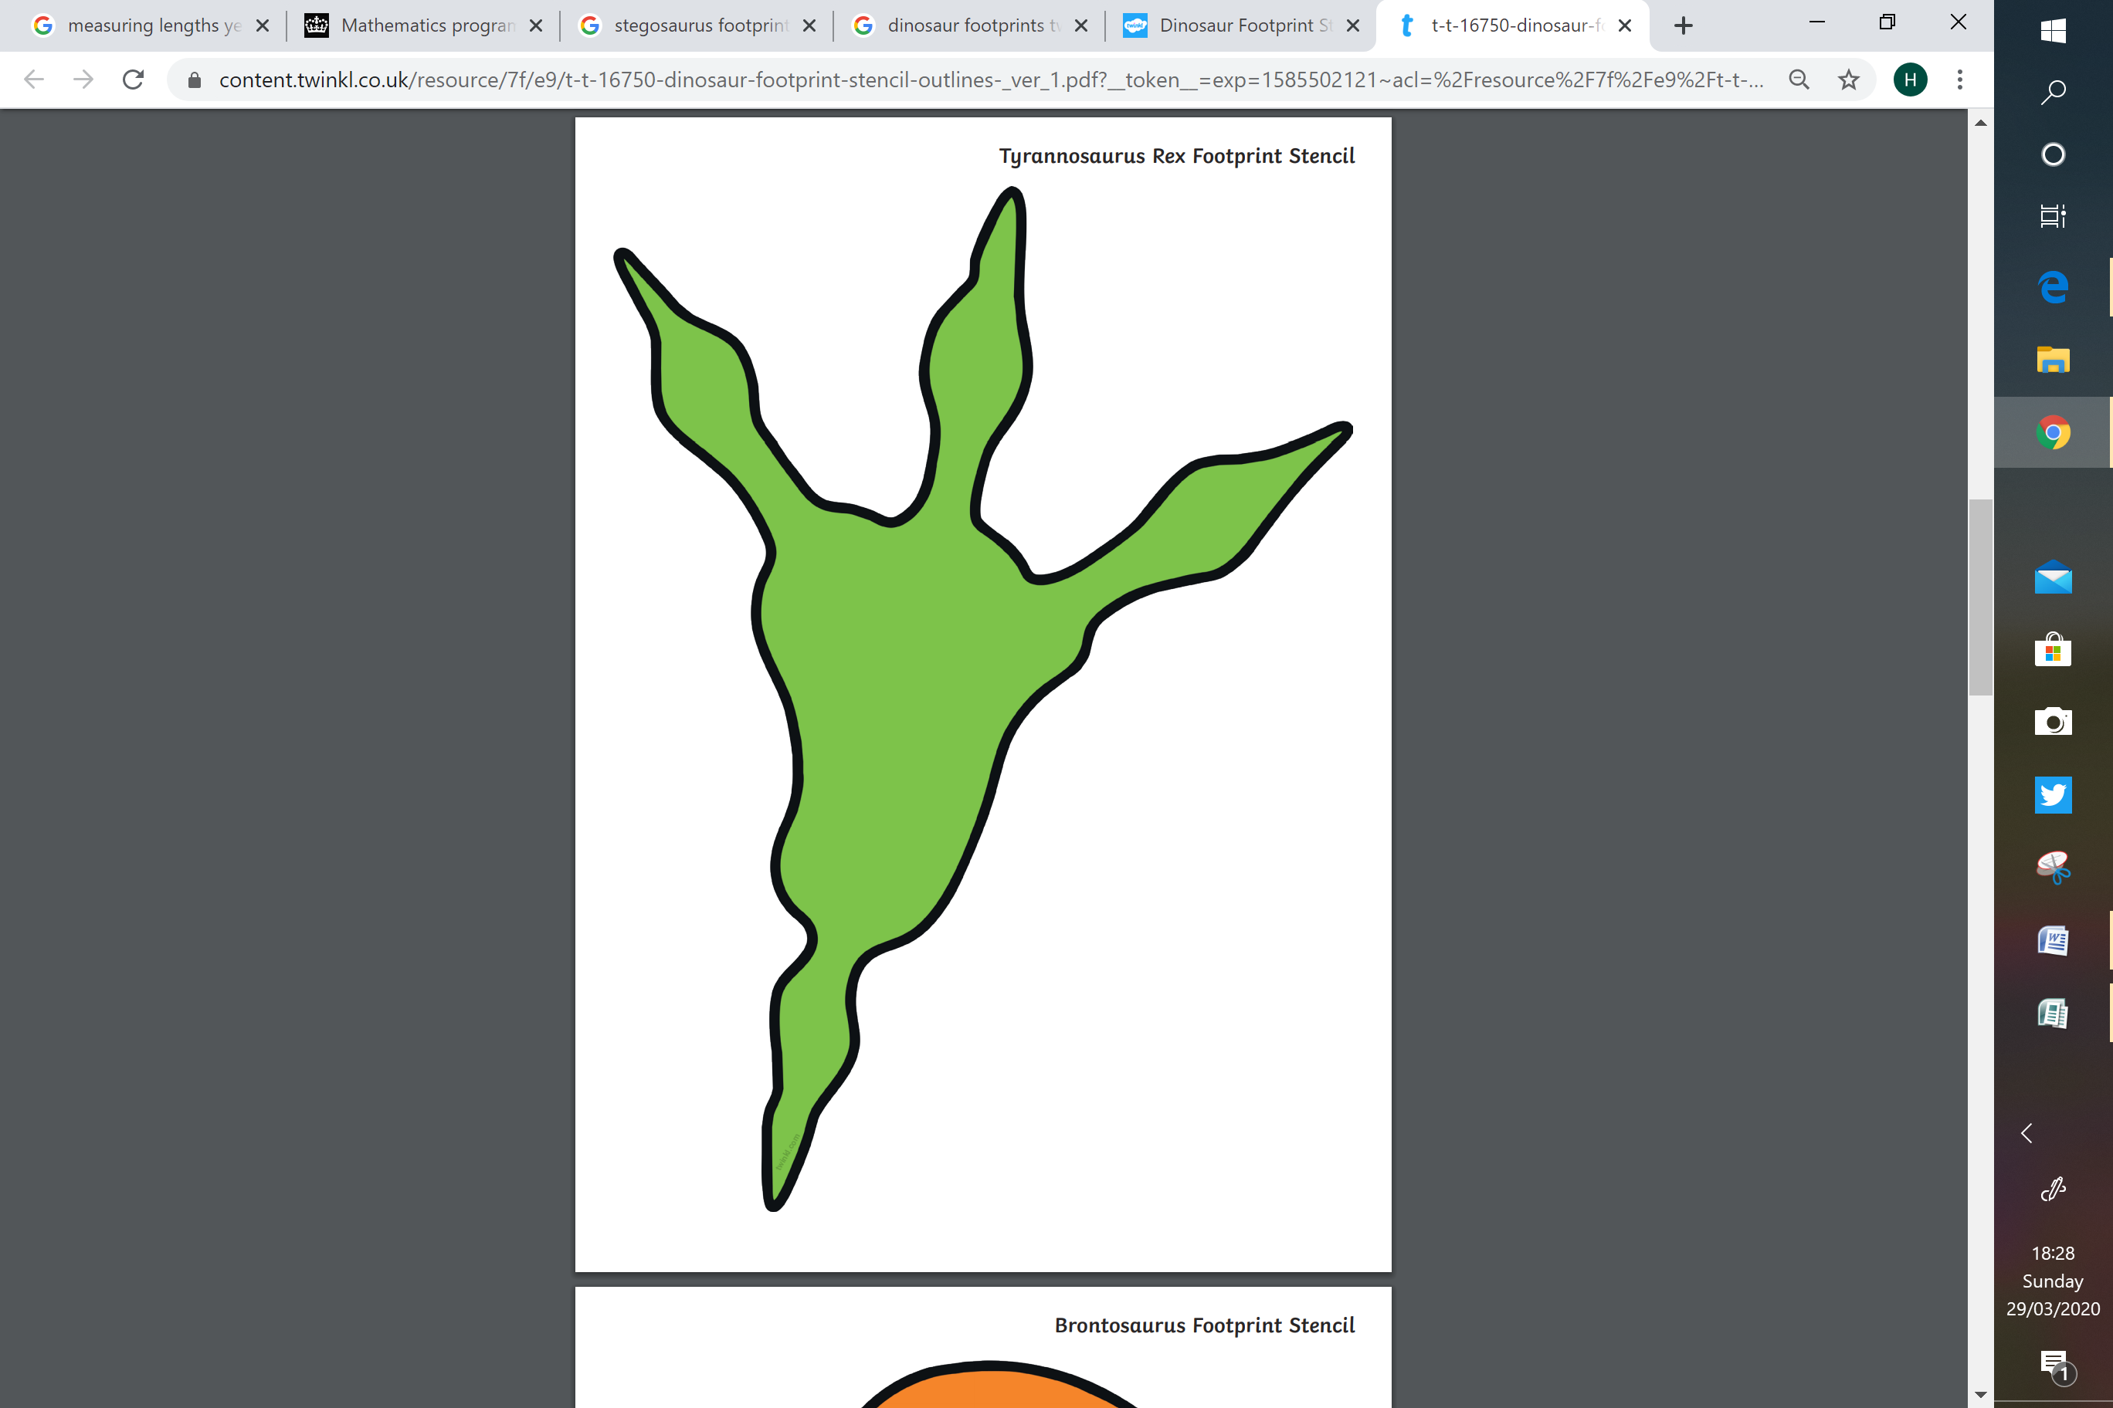

**T-Rex**

Which dinosaur’s footprint was the **longest?**

Which dinosaur’s footprint was the **shortest?**

__________________________________________