

**Paddington’s Travel Diary**

Paddington is travelling across the world visiting different continents!

How many continents are there? __________________

Continent 1: Paddington has landed in ________________________

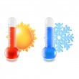

What is the climate like in this continent?

_____________________________________________________________________________________________________________________________________________________________________________________________



What is Paddington going to see / visit? ____________________________________________________________________________________________________________________________________________________________________________________________

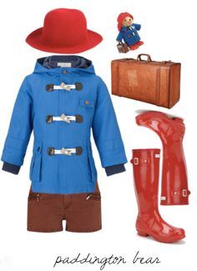

What does Paddington need to wear here?

____________________________________________________________________________________________________________________________________________________________________________________________

Here is a picture of Paddington in ________________ (You could add some labels)