**7 add 3 equals 3 plus 8 equals**

**23.3.20**

1. **Write the answers**

**6 subtract 5 leaves 7 add 3 makes**

**10 add 2 equals 9 add 5 equals**

**8 minus 7 equals 10 minus 4**

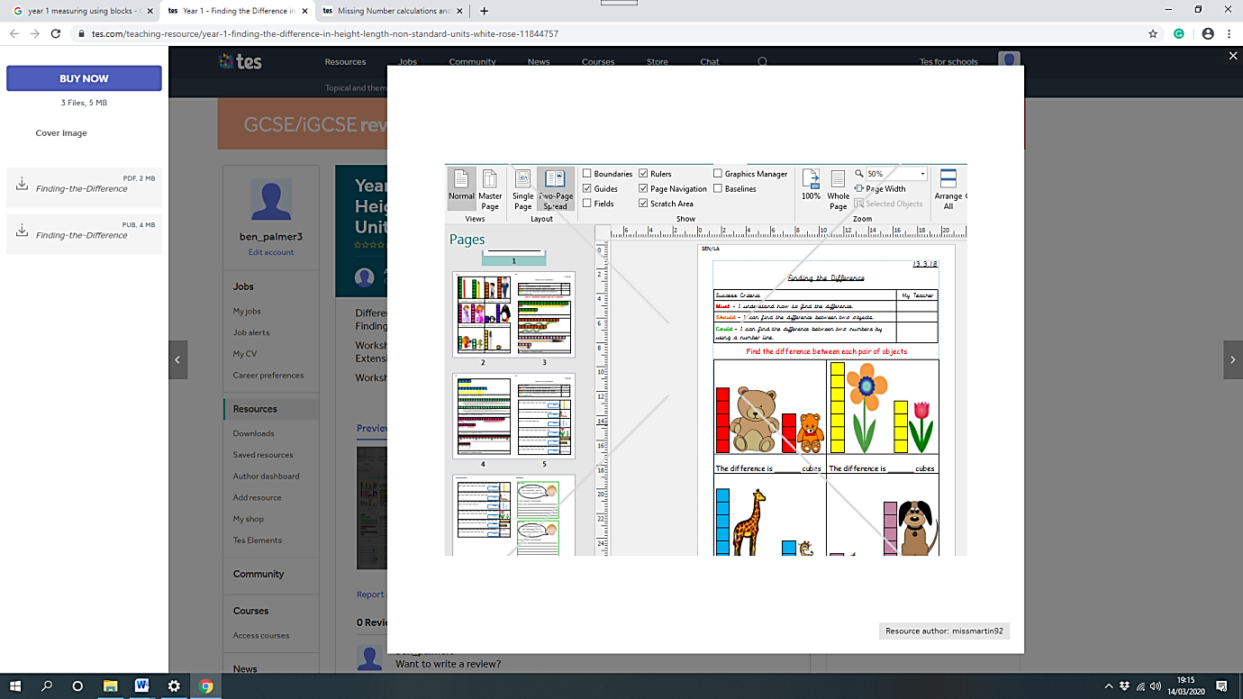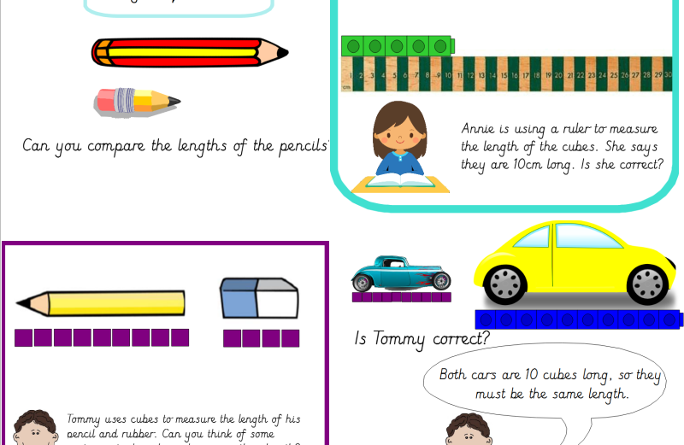**leaves**

**blocks**

**How much taller?**

**blockss**

**blocks**

**B**

**A**

**3. Which flower is taller?**

**blocks**

**blocks**

**How much longer?**

**2. Which object is longer?**