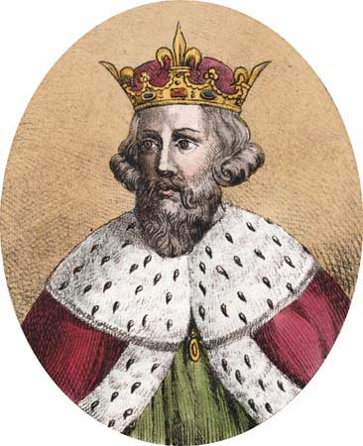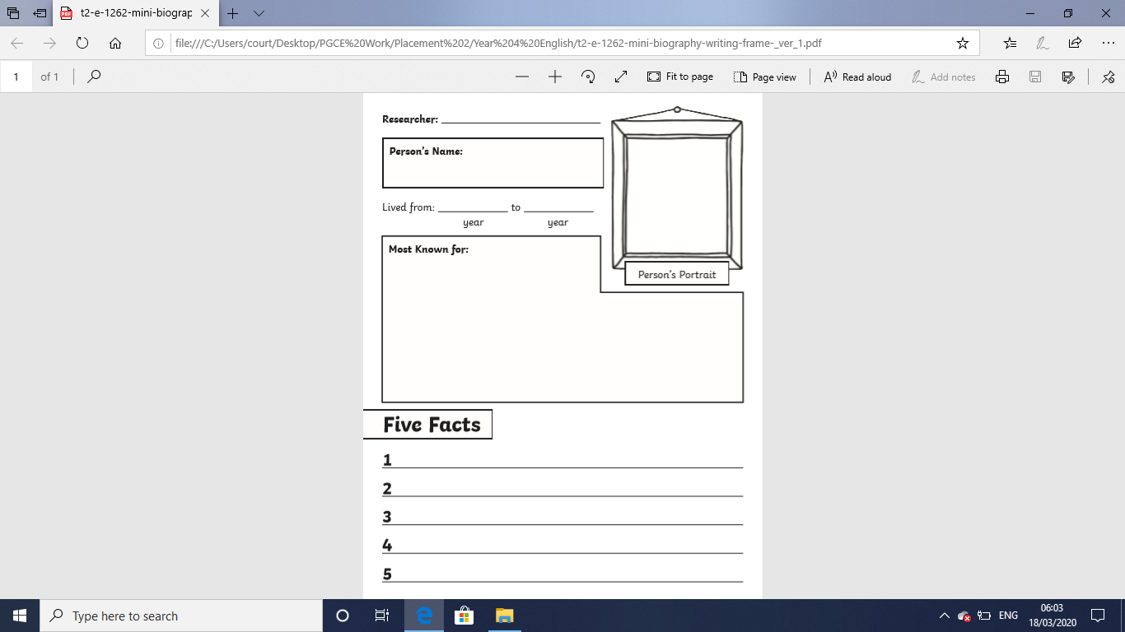LO: To write a Biography based on the life of King Alfred the Great.

**King Alfred the Great**

**King Alfred the Great**