Hutton Rudby
Curriculum News
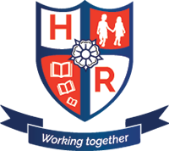

Year 1 – Spring Term 2 – 2018
Our new topic in Year One is ‘Splendid Skies’.
Reminders
Reading books will be changed every Monday, Wednesday and Friday.

PE:
Monday: Yoga 10:30 am
Tuesday: Football 2:15pm

@HuttonRudbyPri
Science
Investigation
Seasonal changes
Computing
Research
Geography Seasonal and daily weather patterns
Art & Design Technology Collage and Painting
PE
Yoga
Football
RE & PSHCE
The Easter Story
History
Significant Individuals –Sir Francis Beaufort
www.huttonrudbyprimary.co.uk

Maths
Addition and subtraction
Money
Shape
Capacity

English
Instructions
Narratives
Poetry
Non-chronological reports

