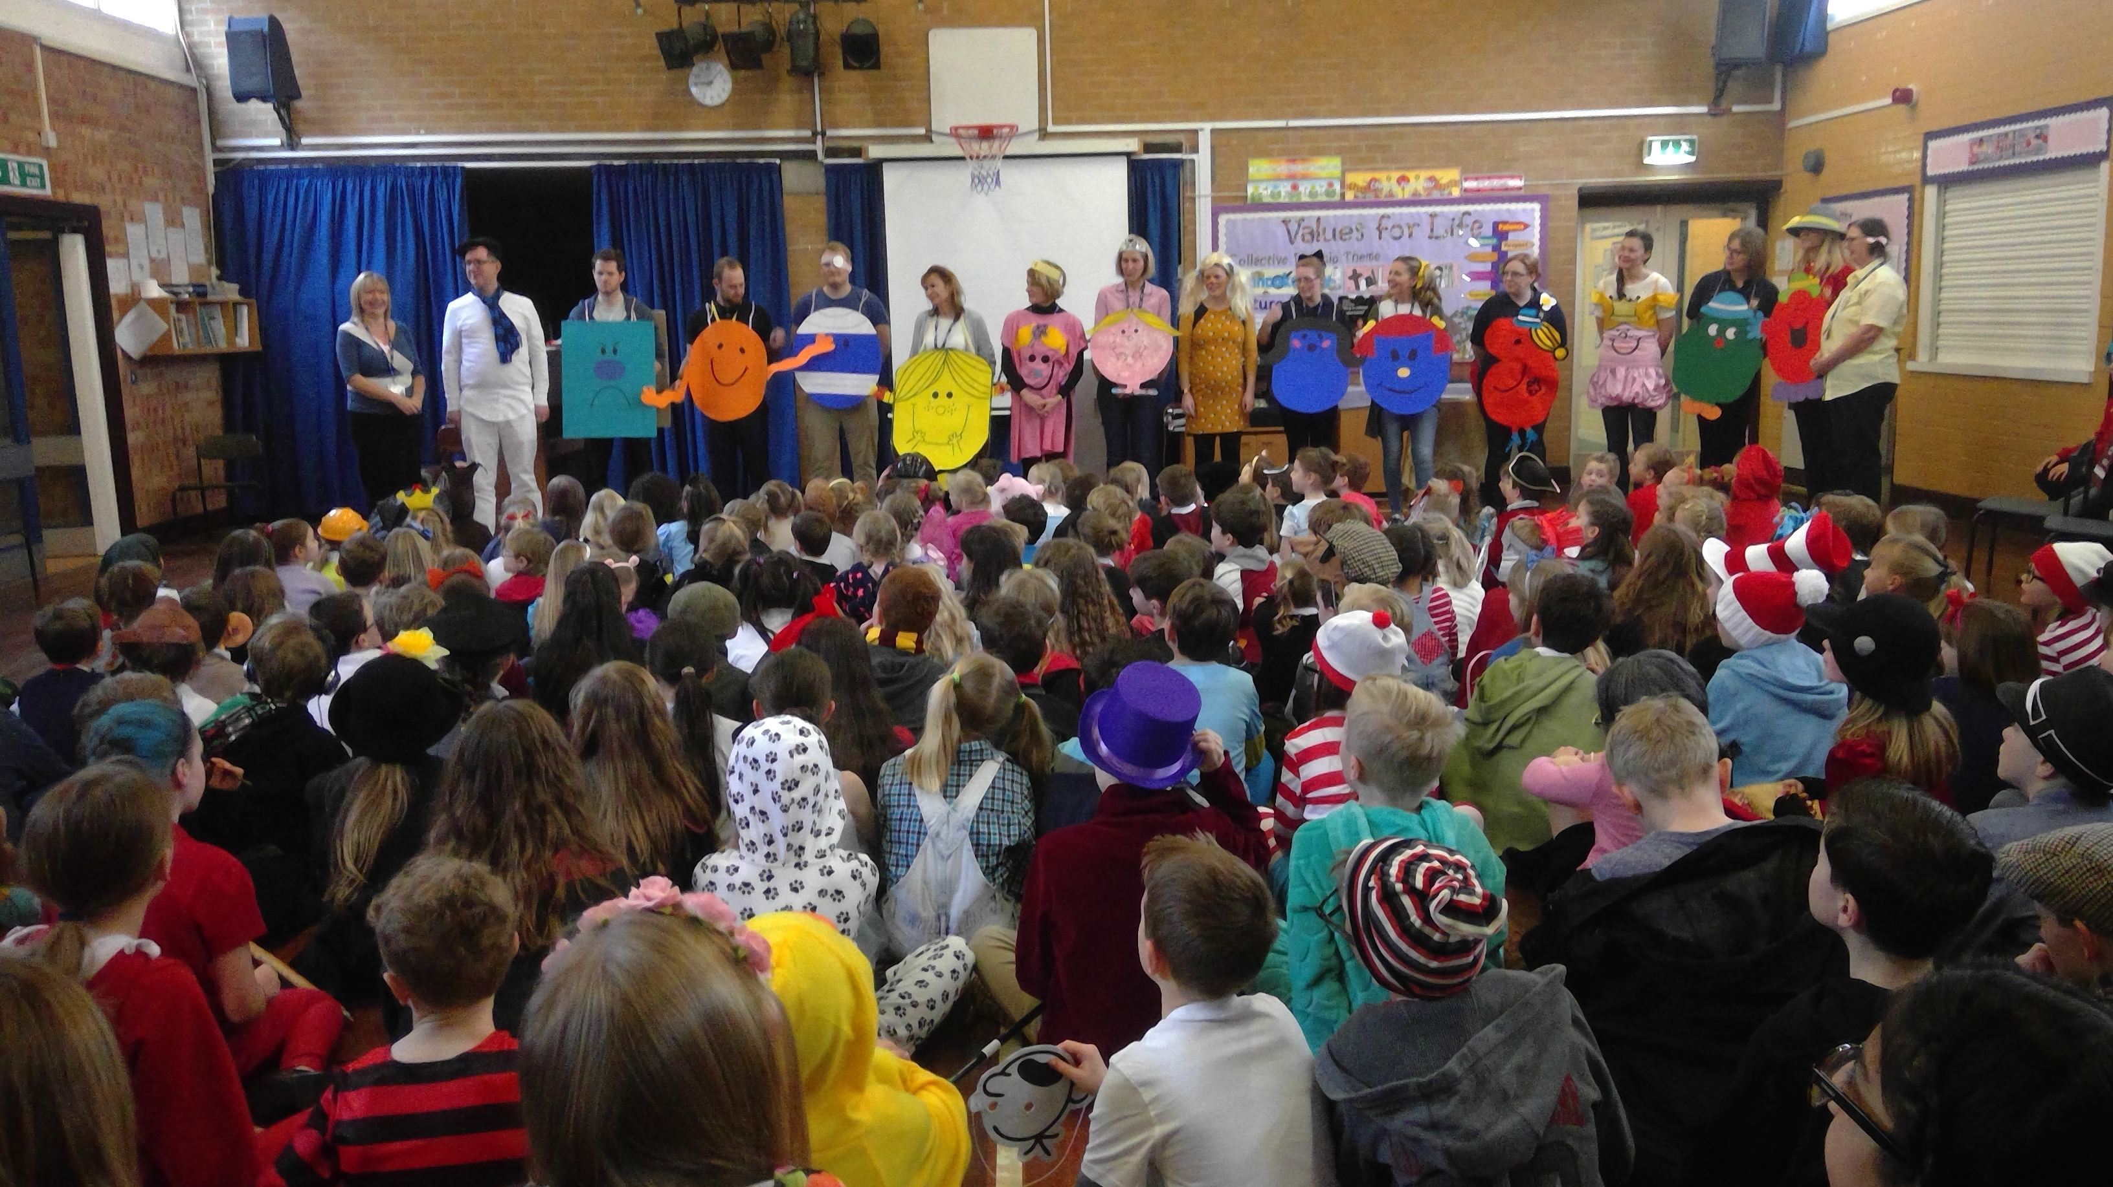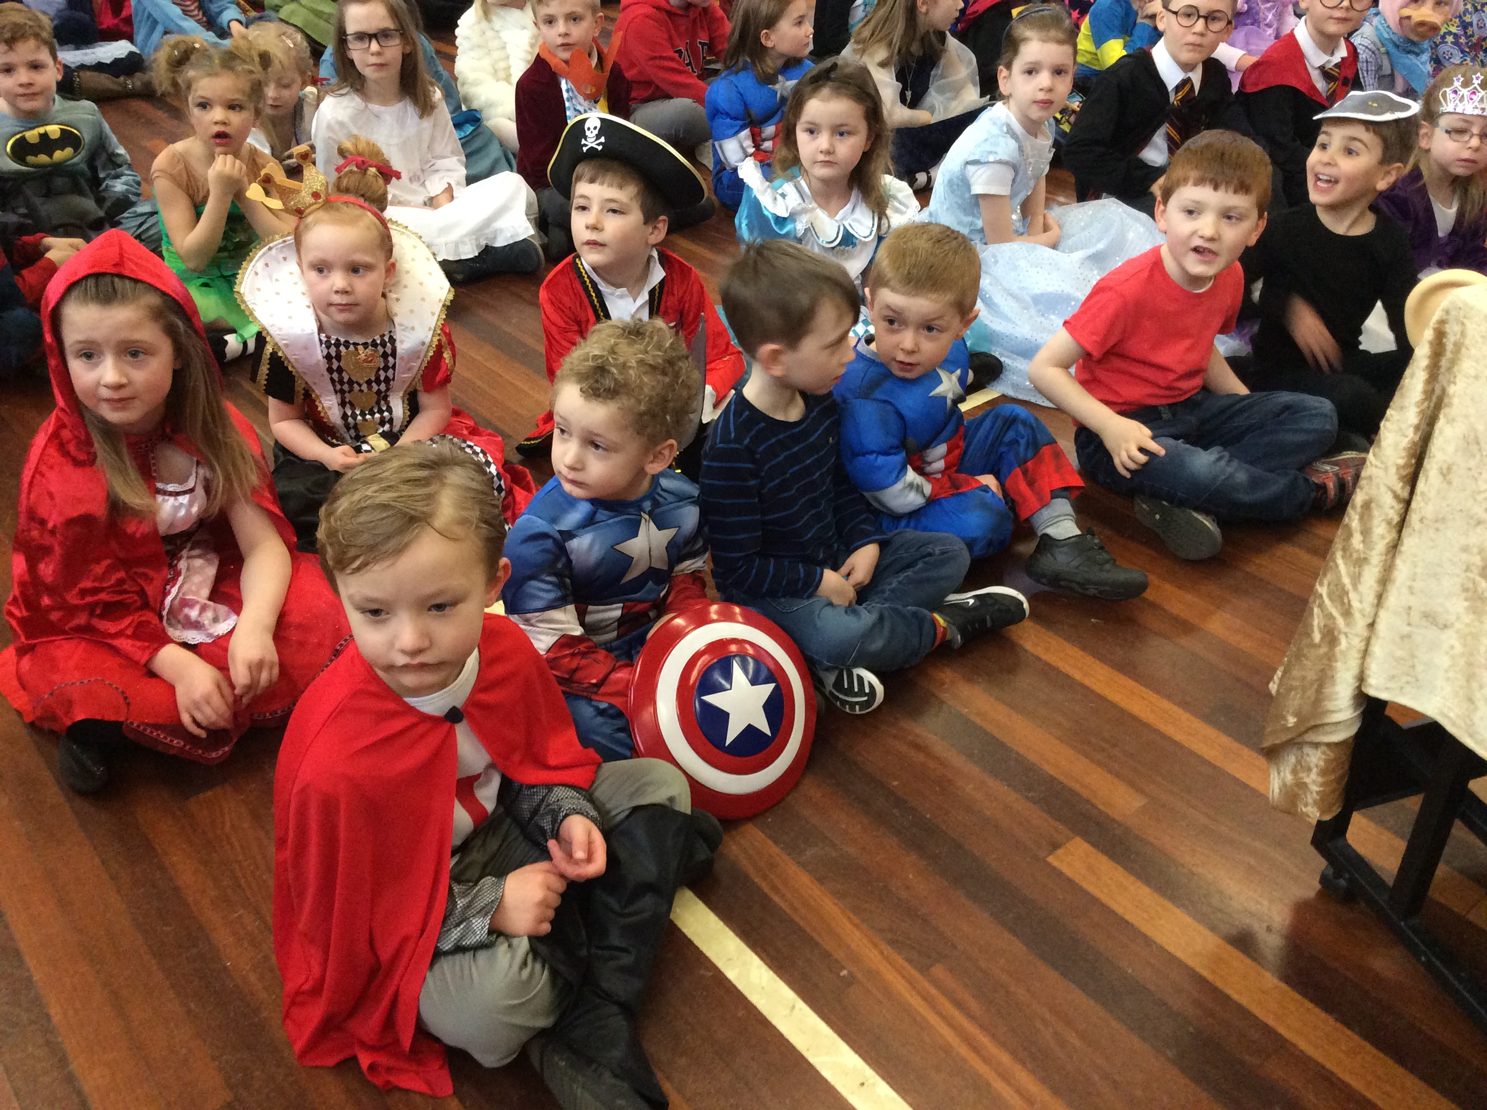 |  | 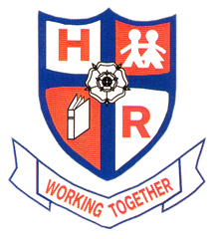  HUTTON  RUDBY  NEWS
there were some fabulous costumes for world book day! |  | March 2017
THE CHICKS HAVE ARRIVED!

Wow, what an unbelievably busy term it has been already, with so much to look forward to! There was great eggcitement (I couldn’t resist) this week when a dozen eggs courtesy of ‘Living eggs’ arrived in our Reception class. I do not know who was more excited, our Reception children, the staff or some of the Year 6 children who were literally full of the joys of Spring exclaiming that ‘we’re going to have chicks’! Thank you for all your cooperation over the last few weeks regarding the erection of our new school fence and internal lobby area. Your support and feedback has been greatly appreciated. As always I love to hear everyone’s ideas about how we can work together to benefit all the children in our school. My door is always open.
Many thanks once again.
Mr M Kelly
CURRENT YEARLY ATTENDANCE
Reception – 96.9% Year 1 – 98.4%
Year 2 - 96.9% Year 3 – 97.1%
Year 4 - 97.7% Year 5 – 97.1%
Year 6 - 96.7%
WEBSITE


I am absolutely delighted with the response that our new school website has received: www.huttonrudbyprimary.sch.uk.The school website will be continuing to evolve with many more new features and information on the way. Our school council are going to become roving news reporters and will be updating the website every fortnight with school news, including reports, interviews and video blogs. Additionally, coming very soon will be weekly maths problems and conundrums added to the website aimed to test the keenest of minds created by our wonderful Year 6 children. What’s more, watch the website closely for our new virtual school tour, again coming soon!
PLEASE KEEP IT SAFE
Mornings and after school can be busy times around school and we appreciate your support in keeping the area safe for our families and local residents. Parking does not appear to be easy around school, but please remember the rights of access for all our neighbours and ensure that all our local residents have enough space to get their own vehicles from their driveways.
HOUSE POINTS

Helmsley - 3720 points
Byland – 3498 points
Rievaulx – 3683 points
Fountains – 3636 points

SCHOOL DINNERS
To help our kitchen staff budget correctly and order food to save waste, please could parents commit to a half term of either school or packed lunches. All the menus can be viewed on our website.
JOB VACANCIES –MSA’s
(midday supervisory assistants)
We are seeking to appoint MSA’S. Working hours 12 -1 pm daily. If you are interested or know of anyone who may be, please call in at the school office for more details.

RED NOSE DAY
Red noses will be on sale for £1 every playtime

‘There is more treasure in books than all the pirate’s loot in treasure island’ Walt Disney

DIARY DATES
Wednesday 8th March 1pm to 3pm Y3/4/5 Quiz competition Richmond Methodist Primary
Wednesday 8th March 1pm to 3pm Y3/4 Quicksticks at Stokesley Comprehensive.
Thursday 9th March Y1/2 Moors Centre Trip visit
Monday 20th March 3:30pm to 6:30pm Parents Evening
Tuesday 21st March 3:30pm to 6:30pm Parents Evening
Thursday 23rd March 1pm to 3pm Cross Country Finals at Dalby Forest
Friday 24th March Red Nose Day – normal school uniform, looking forward to seeing lots of red noses!
Saturday 25th May Y6 football team Youth games finalists at Tadcaster
Wednesday 29th March 3:30pm to 4pm East Barmby Parents meeting
Thursday 30th March 3:30pm to 4pm Bewerley Park Parents meeting
Monday 3rd April 1pm to 3pm Y5/6 Quicksticks at Stokesley Comprehensive
Friday 7th April BREAK UP!
Monday 24th April PD Day
Tuesday 25th April BACK TO SCHOOL TODAY!
Monday 8th May Year 6 SATS WEEK
Monday 8th May to Wednesday 10th May Y5 visit to East Barmby
Monday 15th May to Friday 20th May Y6 visit to Bewerley Park

